

Republic of the Philippines
North Eastern Mindanao State University

Gamification and Interactive Simulation in Digital Logic Education: A platform for Enhancing Conceptual Understanding and Engagement

A Research Paper Presented by:
Cabero, John Mark T.

May 24, 2026

Overview
Digital logic education has, for the better part of the last decade, leaned heavily on software simulation to close a persistent gap: most students never get near actual hardware. Tools like Logisim and Digital Works changed something real. Instead of physical breadboards, expensive ICs, and labs that closed at five o’clock, students could open a laptop and drag gates onto a virtual canvas. The barrier dropped. Practice that once required supervised lab time became something a student could do at midnight, alone, on a personal computer with no equipment beyond the machine itself.
Yet the gap did not close as fully as it appeared. Current simulation tools still leave students staring at static connections, wires and gates that sit inert on screen while the underlying behavior, propagation delay, race conditions, signal timing, remains entirely invisible. Feedback, when it arrives, comes through a teacher’s gradebook days or weeks after the fact. By then, whatever mistake a student made has already been rehearsed enough times to feel correct. Teachers carry the weight of this: manually tracing each submitted circuit, a process that limits how many practice exercises they can realistically assign. And underneath all of it, perhaps the most stubborn problem of all, these tools feel like obligation. Students complete the minimum. Curiosity rarely enters the picture. Many reach the end of a digital logic course with a passing grade and a genuinely fragile understanding of how circuits actually behave.
This study proposes a different approach. LogicPlay is a gamified learning platform built specifically for mobile-first use, where students drag and drop logic gates directly onto their phone screen and watch colored signal animations trace the flow of electricity through each connection in real time. Not a delayed report, immediate visual feedback, the kind that maps abstract behavior onto something the eye can follow. An integrated machine learning grader evaluates submitted circuits instantly, cutting the feedback loop from days to seconds. Points, levels, badges, and time-limited challenges layer on top of the core simulation, not as decoration but as deliberate motivational scaffolding. The whole system ships as a Progressive Web Application, meaning it runs on any device, caches locally, and continues working even when the network drops. The goal is not merely a better simulator. It is a platform where understanding digital logic and actually wanting to practice it might, for once, be the same thing.
General Objective
To develop a gamified platform with interactive simulation and automated feedback that improves conceptual understanding and engagement in digital logic education.
Specific Objectives
- To design a drag-and-drop circuit builder with real-time signal flow animation that helps students visualize abstract gate operations.
- To implement a machine learning-based auto-grading system that provides instant feedback on student circuit submissions.
- To integrate gamification elements including points, level, badges, and challenges that increases student motivation to practice.
- To evaluate the platform’s effectiveness in improving test scores and self- reported engagement compared to traditional simulation tools.

Project Timeline
Figure 1: Gantt Chart for LogicPlay
Figure 1 shows the project timeline from February to May, divided into four months with weekly tasks. February focuses on planning, documentation, and building the backend core. In March the work moves to frontend development, circuit simulation, and starting the machine learning auto-grading system. April is for adding gamification features, completing the PWA offline support, and beginning testing and polishing. May is reserved for final testing, preparing the presentation, making revisions based on feedback, and submitting the completed project. This schedule ensures each part of the system is built step by step, with enough time for testing and improvements before the deadline.
The Gantt chart went through two updates during the project. The first update added a new activity called Documentation Update, scheduled in the last week of March (W9). This update covers the additional contents written for Part III of the research documentation, specifically the sections from 6.0 System Design up to but not including the References. These sections include the development approach, system architecture, use case diagram, data flow diagram, entity relationship diagram, user interface design, test cases, and system requirements. The documentation work for these parts was done alongside the backend and frontend development phase, which is why it falls in that same period.
The second update happened because the original timeline did not account for how much time the testing phase would really take. In the first version of the chart, testing was squeezed into a single week in late April. That was too tight. When I actually started writing and running the test cases for authentication, circuit submissions, classroom management, and gamification, I realized one week was nowhere near enough. Each test case needed ten runs. Some failed and needed debugging. The expired token issue alone took two extra days to trace and document. So I extended the testing bar across two additional weeks, pushing it into the first half of May. This also meant the final presentation preparation and revisions shifted slightly to the right, but they still fit within the original May deadline. The updated chart now shows testing as a continuous block from Week 15 through Week 18, overlapping with the early part of the final documentation and presentation work.
The chart was also updated to reflect the documentation work for Part IV of the research paper. This covers the Results and Discussion, Conclusion, and Recommendation sections. Writing these parts took place in May after the system testing was completed, because the discussion needed to reference the actual test outcomes. The Results and Discussion section pulls together the model training results from Section 7.2 and the functional unit testing results from Section 7.3. The Conclusion and Recommendation sections were written last, since they depend on everything that came before. This update makes the Gantt chart more honest about when the final writing actually happened.
Adding these updates to the chart makes the timeline more accurate and shows that documentation and scheduling are not just done at the start but are updated as the system design becomes clearer and more complete. The final chart reflects what actually happened, not what I hoped would happen back in February.

Statement of the Problem
Several interconnected problems appear to be driving the persistent underperformance of students in digital logic courses, and this study is structured around addressing them in combination rather than in isolation. The most immediate is a visualization deficit. Students work with simulation tools that render circuits as static diagrams, lines connecting boxes, with no indication of how signals actually propagate through gate networks over time. Concepts like propagation delay and glitch behavior remain stubbornly abstract when the tool cannot show them moving. What students see is a snapshot; what they need to understand is a process. The second problem compounds the first: feedback reaches students too late to be corrective. When a teacher manually grades submitted circuits, often days after the fact, the student has already rehearsed whatever error they made enough times to internalize it. Wrong mental models calcify quickly. Hardware access makes these worse, physical components are expensive, lab time is finite, and the opportunity to simply try things and fail cheaply is rarely available outside of supervised sessions. Meanwhile, the manual grading burden on teachers limits how many exercises they can assign, which means students get less practice precisely when practice matters most. Underlying all of this is an engagement problem that tends to go underacknowledged. Current tools offer no intrinsic motivation to explore beyond the assigned minimum. Students complete what is required. The platform proposed here attempts to address the whole picture: real-time visualization, automated feedback, reduced hardware dependency, and engagement mechanisms that make continued practice feel worthwhile rather than obligatory.

6.0 System Design
The design of LogicPlay follows a clear separation between what users see and touch versus what runs behind the scenes. This split matters because circuit simulation needs to feel instant, no one wants to wait for a server to respond while dragging a gate across the screen. The frontend handles the heavy visual work. The backend manages data, users, and grading. They talk to each other only when necessary.

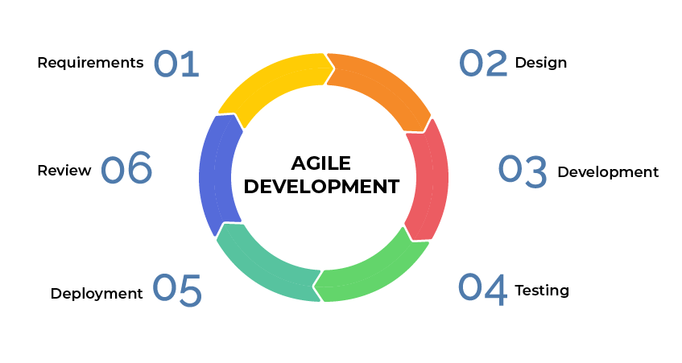
6.1 Development Approach
Figure 2 shows the Agile Development Approach.
LogicPlay follows the Agile development methodology, specifically Scrum. The choice was deliberate, not because Agile is trendy, but because building a circuit simulator with gamification elements involves too many unknowns to plan everything upfront.

6.2 System Architecture.
LogicPlay runs as a decoupled client-server web application with Progressive Web App (PWA) capabilities. Decoupled simply means the frontend and backend can live apart, different servers, different update schedules, different teams could even work on them. This matters for a classroom tool because teachers might use it on school computers while students access it from phones at home. The same backend serves both.
The frontend uses React with Vite as the build tool. Tailwind CSS handles styling with indigo and emerald colors, calm but not boring. The circuit canvas runs on p5.js, a library built for animation and interactivity. Every gate drag, every wire connection, every signal pulse happens right there in the browser. No round trips to a server for basic interaction.
The backend runs FastAPI, a Python framework built for speed and async operations. It exposes a REST API that speaks JSON. When a student submits a circuit, the frontend packages the circuit data as JSON and sends it via HTTP POST. FastAPI validates the data, checks authentication, stores the submission, and runs the auto-grader. The response comes back with a score, possible badges, and level updates. The frontend then updates what the student sees.
Authentication uses JSON Web Tokens (JWT) with passlib for password hashing. No plaintext passwords anywhere. The token system lets the server trust that a request came from who it claims to be without checking the database every single time.
The database is SQLite for development and MVP. SQLAlchemy acts as the ORM, it translates Python objects into SQL queries and back. This keeps the code clean even when the database changes later.
A service worker built with Workbox enables offline caching. Students who lose internet connection can still open the app and work on circuits. Submissions queue up and send when connection returns. The future goal includes full offline circuit play, but the current implementation caches static assets and basic functionality.
System Communication Pattern
The typical flow looks like this:
- A student builds a circuit by dragging gates onto the canvas and connecting wires. The canvas runs entirely client-side, every click responds instantly.
- When ready to submit, the student hits a button. The frontend packages the circuit as JSON.
- The browser sends a POST request to the backend at an endpoint like /api/submissions.
- FastAPI receives the request, checks the JWT to know which student submitted, and validates the circuit data structure.
- The backend evaluates the circuit. This could be rule-based checking (does the truth table match?) or eventually a machine learning model that understands correct circuit patterns.
- The backend saves the submission to the database and computes a score.
- The response returns to the frontend with the score, any earned points, and badge unlocks.
- React updates the UI, shows a "Mission Complete" message, increments the level bar, plays a badge animation.
- All of this happens in seconds. The student gets feedback immediately, not next week.
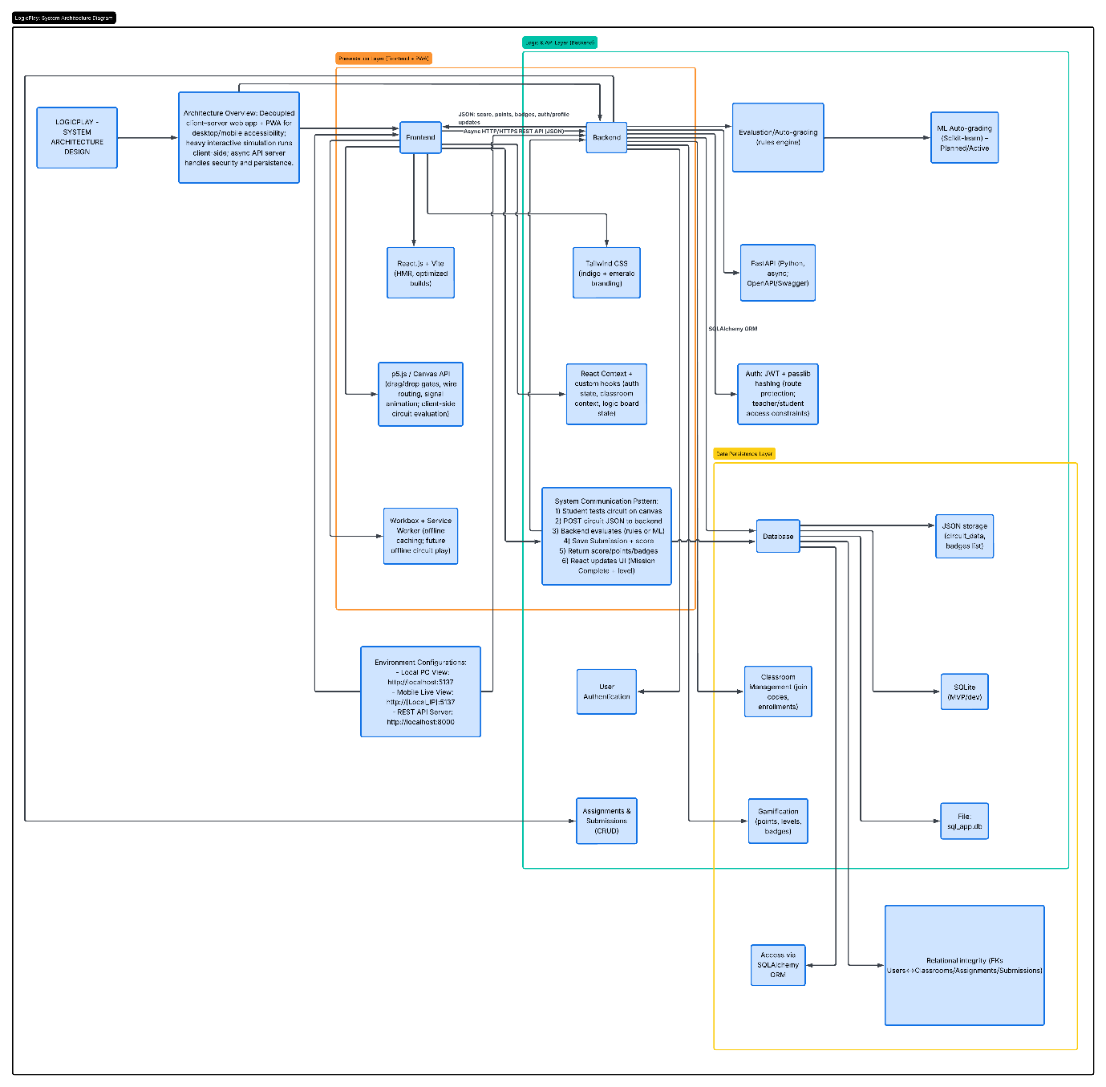
Figure 3 shows the System Architecture Design
Figure 3 illustrates the complete architecture. The frontend block contains the React components, the p5.js canvas, Tailwind styling, and the Workbox service worker. Arrows show data flowing to and from the backend via HTTPS. The backend block shows FastAPI handling requests, SQLAlchemy managing database operations, and JWT handling authentication. The database block lists the main tables. The diagram makes clear what runs where, the browser handles the interactive parts, the server handles persistence and security.
6.3 Use Case Diagram
The use case diagram defines who can do what inside LogicPlay. Two primary actors exist: the Student and the Teacher. There is also one secondary actor called the Autograding System, which is the machine learning model and heuristic checker that scores circuits automatically. Each actor has different needs and different permissions.

Student Actions
A student enters the system by registering an account or logging in. If the system detects a new device, it asks for a verification step. This keeps student accounts safe. Once inside, the student can change their password and edit their profile.
The student joins a classroom using a join code. No manual approval is needed unless the teacher turns on enrollment approval. The join code is a short code the teacher shares.
The core student activity is designing logic circuits. The drag and drop interface lets them build circuits on a canvas. They can simulate the circuit in real time and watch signals flow through every connection. Students can save their work and load it later. They can also save circuits offline and sync them when the internet comes back. A generate report feature lets them export their circuit as a PDF or soft copy for submission outside the system.
Students view active assignments from their enrolled classrooms. They submit circuits directly for those assignments. If they change their mind, they can dismiss or reset an assignment and start over. They can also view their own submissions list to track what they have turned in.
For gamification, students can view the leaderboard to see how they rank against classmates. They track their XP, level, and badges from their profile. They can also browse challenges, which are optional missions separate from regular assignments that give extra points.

Teacher Actions
Teachers also register and log in like students. They have profile management and device verification too.
Teachers create classrooms. Each classroom gets a unique join code. Teachers can manage classroom details, like renaming the class, regenerating the join code if needed, or deleting a classroom entirely. They can approve student enrollments if they want to control who joins. They can also remove students from a class. A classroom analytics dashboard shows them how their students are doing.
Teachers create assignments with a title, description, due date, points reward, and optional target gate restrictions. They can edit or delete assignments later. They can view all submissions from their students for each assignment.
For grading, teachers can manually grade and give feedback on submissions. The system also provides an auto score, but the teacher has the final say. Teachers can also use the circuit builder and simulation to create example circuits or test assignments themselves. They can view the leaderboard to see student progress across their classes.

The Autograding System
This is a secondary actor. It is not a person. It is the machine learning model and heuristic checker that runs in the background. When a student submits a circuit for an assignment, the system automatically includes the auto scoring step. The autograding system checks the circuit truth table and structure and returns a score instantly. This happens without the teacher doing anything.

System Boundaries
The use case diagram includes a system boundary labeled "LogicPlay System." Everything inside this boundary is what LogicPlay handles. Registration, login, classroom management, circuit design, simulation, assignments, submissions, grading, gamification, and reporting are all inside. The autograding system sits outside the main boundary but connects to the auto score use case through a secondary actor relationship. This shows that the grading intelligence is a separate component that the main system calls when needed.

Relationships Between Use Cases
There are two important relationships in this diagram.
The first is between Login and Verify Device. If the system sees a login attempt from a device it does not recognize, it extends the login process by asking for a verification step. This is an extend relationship because it only happens sometimes, not every login.
The second is between Submit Circuit for Assignment and Auto Score Circuit Submission. Every time a student submits a circuit, the auto scoring step is always included. This is an include relationship because it happens every single time without exception.

Changes from the Previous Version
The updated use case diagram adds several things that were missing before.
Students can now verify their device during login. This adds security without making the process harder for recognized devices.
Students can generate circuit reports as PDF or soft copies. This was added because some teachers still want printed or file submissions for their own records.
Students can save circuits offline and sync later. This was part of the PWA offline support but was not shown in the old diagram.
Teachers now have more control over classrooms. They can manage classroom details, approve enrollments, and remove students. These were implied before but not explicitly shown.
Teachers can also use the circuit builder and simulation tools. The old diagram only showed students doing design work. In reality, teachers need to build example circuits too.
The autograding system now appears as a separate actor. The old diagram kept grading inside the main system. Separating it makes the architecture clearer and shows that the machine learning model is its own component.
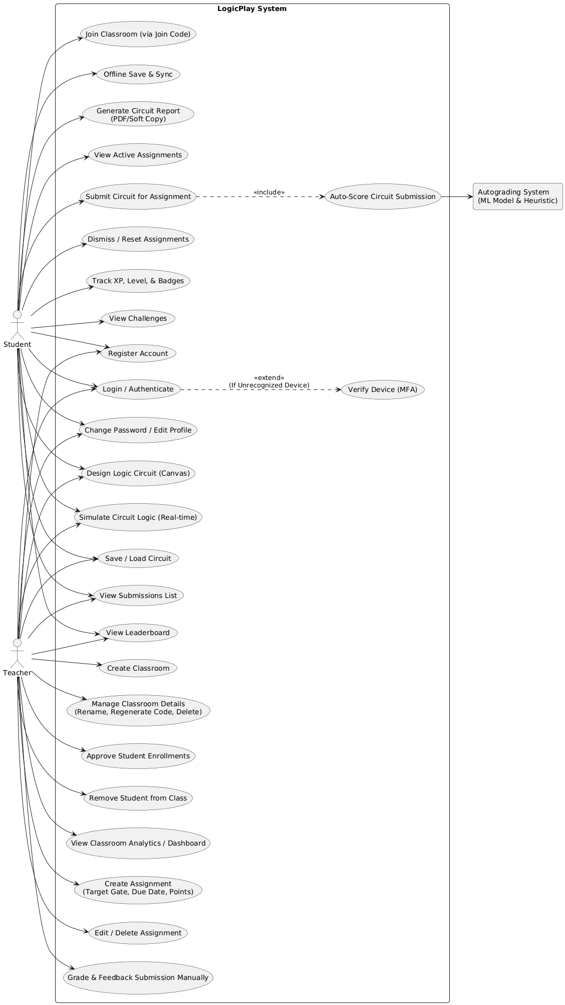
These changes make the use case diagram more complete and more honest about what the system actually does.

Figure 4: LogicPlay System Use Case Diagram (Generated using PlantText).
Figure 4 shows all use cases and their relationships. The student actor connects to sixteen use cases spanning registration, classroom enrollment, circuit design, simulation, saving, reporting, assignment handling, submission viewing, and gamification. The teacher actor connects to fourteen use cases covering account management, classroom creation and management, assignment handling, submission viewing, manual grading, and access to the circuit builder and leaderboard. The autograding system connects to one use case for automatic scoring. The diagram uses standard UML notation with stick figures for actors and ellipses for use cases. Solid lines show associations. Dashed lines with arrows show include and extend relationships. The system boundary groups all LogicPlay functionality into one clear rectangle.

6.4 Data Flow Diagram
Data flow diagrams trace how information moves through the system. Two levels are presented: Level 0 (context diagram) shows the system as a single process with external entities. Level 1 breaks that single process into smaller processes and shows data stores.
Level 0: Context Diagram
At the highest level, LogicPlay interacts with two external entities: Student and Teacher. Data flows in both directions.
From Student to System:
- Login and registration information
- Join code for enrollment
- Circuit submissions
- Assignment answers
- From System to Student:
- Authentication tokens
- Mission reports showing performance
- Feedback on submissions
- Points and badge notifications
From Teacher to System:
- Login information
- Classroom and assignment data
- Graded scores and feedback
- From System to Teacher:
- Authentication tokens
- Student submissions for gradin
- Progress analytics and reports
The context diagram treats the entire system as a black box. We don't care what happens inside, only what enters and leaves. This helps identify all external dependencies before designing internal details.
Level 1: Logical DFD
The Level 1 diagram opens the black box. Six processes handle the work:
Process P1 (User Authentication): Handles login, registration, and token validation. It checks credentials against user records and issues JWTs for valid sessions. All other processes depend on P1 to know who is making requests.
Process P2 (Classroom Management): Creates classrooms, generates join codes, handles enrollments, and manages classroom rosters. When a student submits a join code, P2 validates it and creates an enrollment link between student and classroom.
Process P3 (Circuit Design & Simulation): This runs primarily on the frontend but the diagram shows it as a process because data still flows. The student interacts with the canvas; circuit data is stored temporarily in browser state and sent to the backend only on submission.
Process P4 (Assignment & Submission Management): Teachers create assignments through P4. Students submit work to P4. The process stores submissions, tracks due dates, handles late submissions, and maintains submission status (pending, graded, returned).
Process P5 (Evaluation & Grading): The auto-grader lives here. P5 receives circuit JSON, evaluates correctness against expected behavior, and returns a score. For teacher grading, P5 provides the interface to review submissions and add manual scores and feedback.
Process P6 (Gamification & Progression): Tracks points, levels, and badges. When a submission gets graded, P6 checks if new thresholds were crossed, did the student just reach 100 points? Level up. Did they complete a difficult challenge? Award a badge. P6 also sends notifications to keep students informed of their progress.
Data Stores
Seven data stores support these processes:
- D1 (User Records): Stores usernames, password hashes, roles (student/teacher), points, levels, and earned badges. The users table in the ERD maps directly to this store.
- D2 (Classroom Data): Stores classroom names, join codes, creation dates, and teacher ownership information.
- D3 (Enrollments): Links students to classrooms. A single student can be in multiple classrooms; a single classroom contains many students
- D4 (Assignments): Stores assignment details, title, description, due date, point reward, target gate specifications.
- D5 (Submissions): Stores circuit JSON, auto-scores, teacher scores, teacher feedback, submission timestamps, and late status.
- D6 (Badge Definitions): Stores badge names, descriptions, and the requirements to earn them (e.g., "score 100% on three assignments" or "complete five circuits in one week").
- D7 (Challenge Data): Stores optional challenge missions separate from regular assignments. Challenges are self-directed; students attempt them for extra points and badges.
Data Flow Examples
Student submits assignment:
- Student → P4 (circuit data) → D5 (store submission) → P5 (evaluate) → D1 (update points) → P6 (check badges) → D5 (update score) → Student (return feedback)
- Teacher creates classroom:
- Teacher → P2 (classroom details) → D2 (store classroom) → P2 (generate join code) → Teacher (return join code)
- Student joins classroom:
- Student → P2 (join code) → D2 (validate code) → D3 (create enrollment) → Student (confirmation)
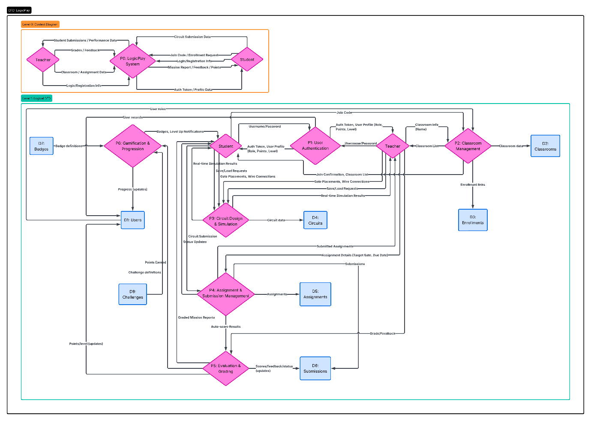
Figure 5: Data Flow Diagram Level 1 of LogicPlay
Figure 5 presents the complete Level 0 and Level 1 DFD. The diagram uses open-ended rectangles (parallel lines) for data stores, rounded rectangles for processes, and arrows for data flows. External entities (Student and Teacher) appear at the edges. The six processes are arranged logically: authentication on the left, classroom and assignment management in the middle, evaluation and gamification on the right. Data stores sit between processes that use them. The diagram shows, for example, that P4 (Assignment & Submission Management) reads from D2 (Classroom Data) and D4 (Assignments), writes to D5 (Submissions), and also reads from D5 when retrieving existing submissions. The complexity is manageable, a sign of good decomposition.

6.5 Entity Relationship Diagram
The physical ERD defines exactly how data lives in the database. Each table, each column, each foreign key appears here. This is the blueprint SQLAlchemy follows to create the actual database.
Users Table
The users table is the heart of the system. Every person who uses LogicPlay, may it be student or teacher, it has one row here.
- user_id (PK, integer): Auto-incrementing primary key. Never exposed to users.
- username (unique, text): The login name. Students pick their own; teachers probably use email addresses.
- password_hash (text): Not the actual password. A bcrypt or similar hash. Even if the database leaks, passwords remain safe.
- role (enum: student/teacher): Determines permissions. A teacher can create classrooms; a student cannot.
- points (integer): Running total of earned points. Starts at zero.
- level (integer): Derived from points. More points means higher level. The exact formula is configurable.
- created_at (timestamp): When the account was created. Useful for analytics.
Classrooms Table
Classrooms group students under a teacher's supervision.
- classroom_id (PK, integer): Unique identifier.
- teacher_id (FK → users.user_id): Which teacher owns this classroom. A teacher can have many classrooms.
- name (text): Display name like "CS3A - Digital Logic Spring 2026"
- join_code (text, unique): Six-character code students type to enroll. Generated randomly when the classroom is created.
- created_at (timestamp): Creation date.
Enrollments Table
- This is a junction table. It connects students to classrooms. Many-to-many relationships need a third table.
- enrollment_id (PK, integer): Surrogate key.
- student_id (FK → users.user_id): The student joining.
- classroom_id (FK → classrooms.classroom_id): The classroom being joined.
- enrolled_at (timestamp): When enrollment happened. Useful for tracking dropouts.
Assignments Table
Teachers create assignments inside classrooms.
- assignment_id (PK, integer): Unique identifier.
- teacher_id (FK → users.user_id): Who created this. Denormalized slightly for quick access.
- classroom_id (FK → classrooms.classroom_id): Which classroom this belongs to.
- title (text): Short name like "NAND to XOR Challenge"
- description (text): Longer explanation, possibly with hints.
- target_gate (text, nullable): If specified, restricts which gates students can use. "NAND only" is a common constraint.
- due_date (timestamp, nullable): When submissions stop being on time.
- accept_late (boolean): Can students submit after the due date? Sometimes yes, with penalty.
- points_reward (integer): Base points for completion. Bonus points possible for excellence.
- created_at (timestamp): Creation date.
Submissions Table
Every time a student submits an assignment, one row appears here.
- submission_id (PK, integer): Unique identifier.
- assignment_id (FK → assignments.assignment_id): Which assignment these answers.
- student_id (FK → users.user_id): Who submitted.
- circuit_data (JSON or text): The complete circuit description. Gates, wires, positions, everything needed to reconstruct the visual.
- auto_score (integer, nullable): Score from the automatic grader. 0 to 100 scale.
- teacher_score (integer, nullable): Score from the teacher. Overrides auto_score if present.
- teacher_feedback (text, nullable): Comments from the teacher.
- submitted_at (timestamp): When the submission arrived.
- is_late (boolean): True if submitted after due_date.
- status (enum: pending/graded): Pending means the teacher hasn't reviewed it yet. Graded means done.
Badges Table
- Badges are achievements. This table defines what badges exist.
- badge_id (PK, integer): Unique identifier.
- name (text, unique): "Logic Master" or "Perfect Submission"
- description (text): "Earned by scoring 100% on five assignments"
- requirement_type (text): What kind of achievement triggers this. Options: "score_threshold", "streak", "challenge_complete"
- requirement_value (integer): The number that matters. For score_threshold, maybe 100. For streak, maybe 3.
User Badges Table (implied but not shown in the diagram
Students earn badges. A separate table would link users to badges with an earned_at timestamp. The provided ERD shows badges linked directly in the users table via a "badges" column, but that's denormalized. The proper normalized design uses a junction table. The implementation will use the junction table approach.
Circuits Table (for saved drafts)
- Students might save circuits without submitting. The circuits table handles this.
- circuit_id (PK, integer): Unique identifier.
- user_id (FK → users.user_id): Who owns this draft.
- circuit_data (JSON): The saved circuit.
- score (integer, nullable): If auto-graded, store the score.
- feedback (text, nullable): Auto-grader feedback.
- created_at (timestamp): When the draft was created.
Challenges Table
- Challenges are optional missions separate from regular assignments.
- challenge_id (PK, integer): Unique identifier.
- title (text): "The XOR Challenge"
- description (text): "Build an XOR gate using only AND, OR, and NOT gates"
- target_gate (text, nullable): The gate students must produce.
- gate_count (integer, nullable): Limit on how many gates can be used.
- points_reward (integer): Points for completion.
Relationships Summary
- A User can own many Classrooms (one-to-many via teacher_id)
- A User can be enrolled in many Classrooms (many-to-many via Enrollments)
- A Classroom has many Assignments (one-to-many)
- An Assignment has many Submissions (one-to-many)
- A User has many Submissions (one-to-many)
- A User can earn many Badges (many-to-many, implied)
- A User can save many Circuits (one-to-many)
Indexing Strategy
- Performance matters even for a small system. Indexes go on:
- username in users table (for login lookups)
- join_code in classrooms table (students join by code)
- classroom_id in assignments table (show assignments for a classroom)
- assignment_id in submissions table (show submissions for an assignment)
- student_id in submissions table (show all submissions by one student)
- submitted_at in submissions table (sorting by date)
- SQLite handles these indexes efficiently. The database stays small enough that indexes aren't strictly necessary, but they're good practice.
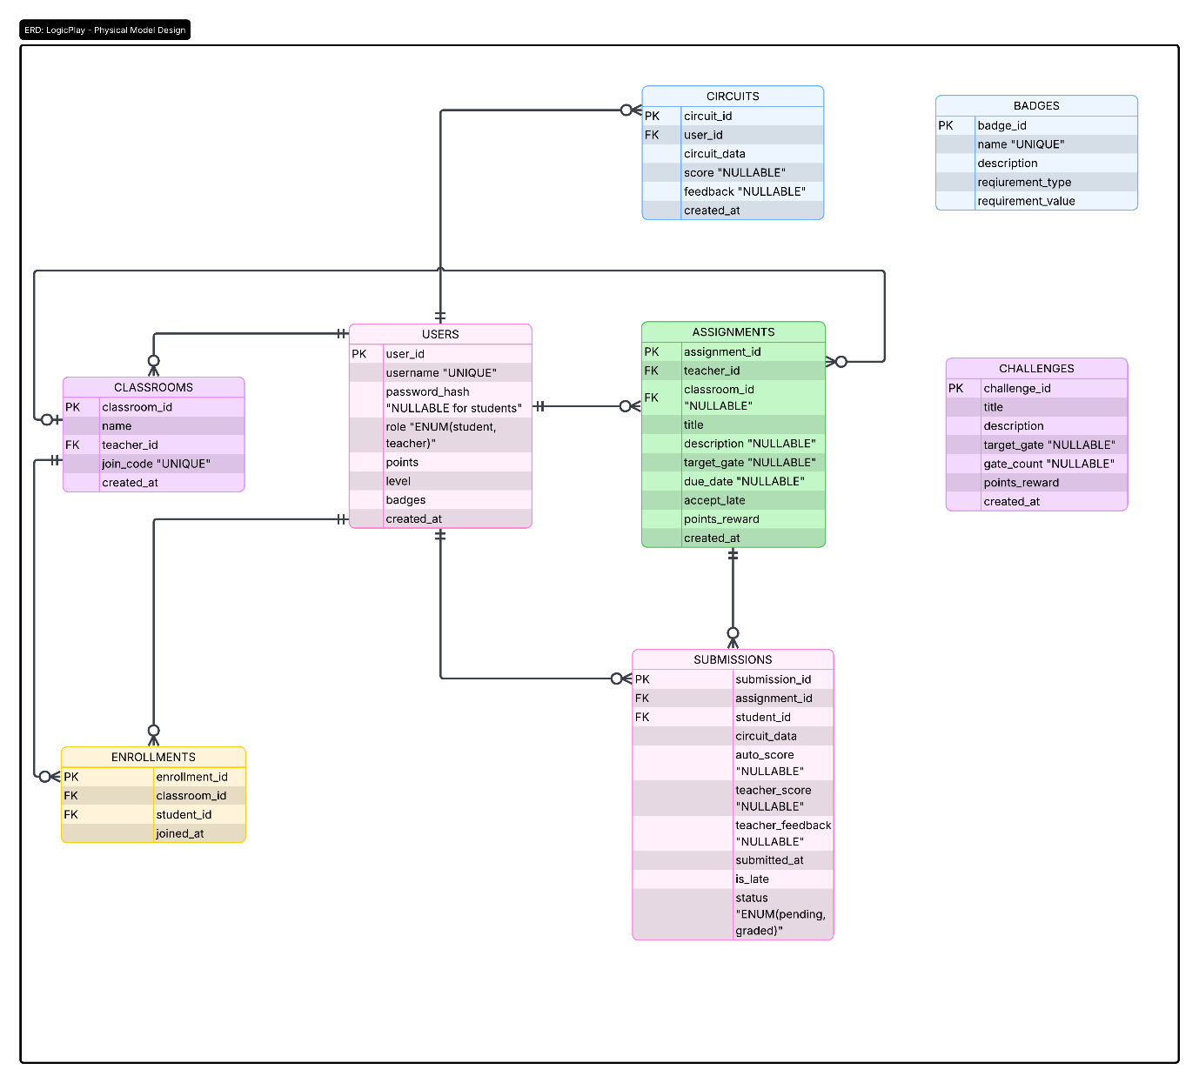
Figure 6: Entity Relationship Diagram of LogicPlay
Figure 6 shows the complete physical ERD. Tables appear as boxes with column lists. Primary keys have "(PK)" after them. Foreign keys have "(FK)" and an arrow pointing to the referenced table. The diagram uses crow's foot notation. lines with three-pronged ends for "many" relationships, single lines for "one." For example, the line from Users to Classrooms has a crow's foot near Classrooms and a single line near Users, meaning one user can own many classrooms but each classroom belongs to exactly one user. The Enrollments table sits between Users and Classrooms with crow's feet on both sides, so many students can enroll in many classrooms. The diagram is readable at a glance but contains all details needed for implementation.
6.6 User Interface Design
The interface balances two realities: students use phones, teachers use laptops. What works on a 24-inch monitor breaks on a 6-inch screen. So LogicPlay adapts, not through a separate mobile app, but through responsive design that reflows the same interface and experience.
Design Philosophy
Three principles guide the interface. First, show the circuit canvas first. Everything else like components, controls, challenges that can slide, collapse, or hide. The canvas is the work. Second, empty states must explain themselves. A blank screen with no guidance frustrates. A blank screen that says "Drag gates here to start building" teaches. Third, gamification elements (XP, levels, badges) appear everywhere but never block the main task. Progress is motivation, not distraction.
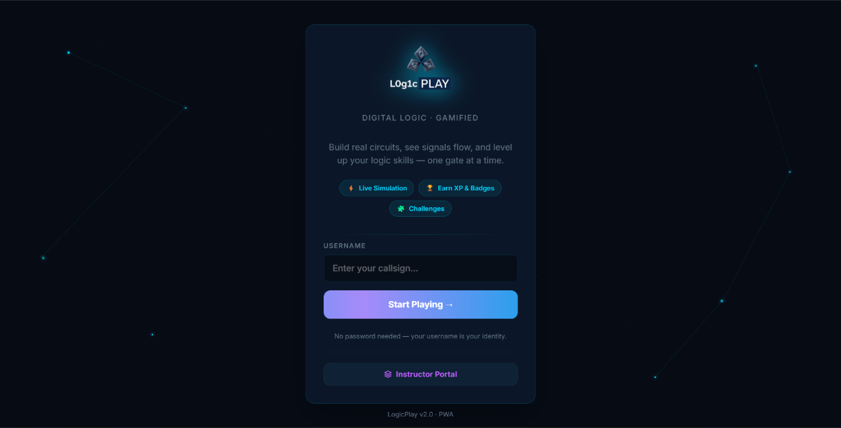
6.6.1 Landing Page
Figure 7: LogicPlay’s Landing Page (Deskto/PC view)
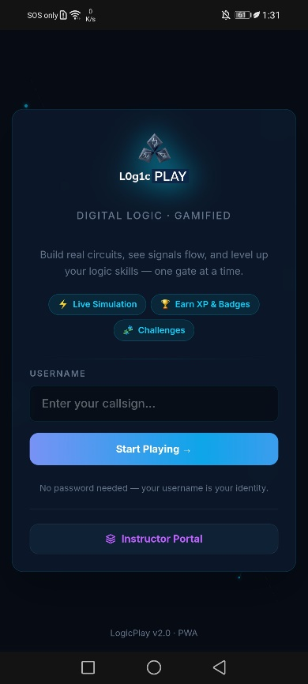
Figure 8: LogicPlay’s Landing Page (Mobile view)
The entry point is direct. "LogicPlay" appears with a stylized '1' replacing the 'i', a small nod to binary. The tagline reads "Digital Logic · Gamified." Below that, a short pitch: "Build real circuits, see signals flow, and level up your logic skills, one gate at a time."
Three feature badges sit beneath: "Live Simulation," "Earn XP & Badges," and "Challenges." These aren't decoration. They telegraph the core value before the user commits to anything.
The main action is a single field: "USERNAME" with placeholder "Enter your callsign..." No password for students. The design decision is intentional, young users forget credentials. Removing that friction means more practice, fewer help desk tickets. A button labeled "Start Playing →" submits.
Below the button, a note clarifies: "No password needed, your username is your identity." At the bottom, "Instructor Portal" links to teacher login. Small text reads "LogicPlay v2.0 · PWA”, the user knows this works offline.
6.6.2 Teacher Portal - Sign In and Registration
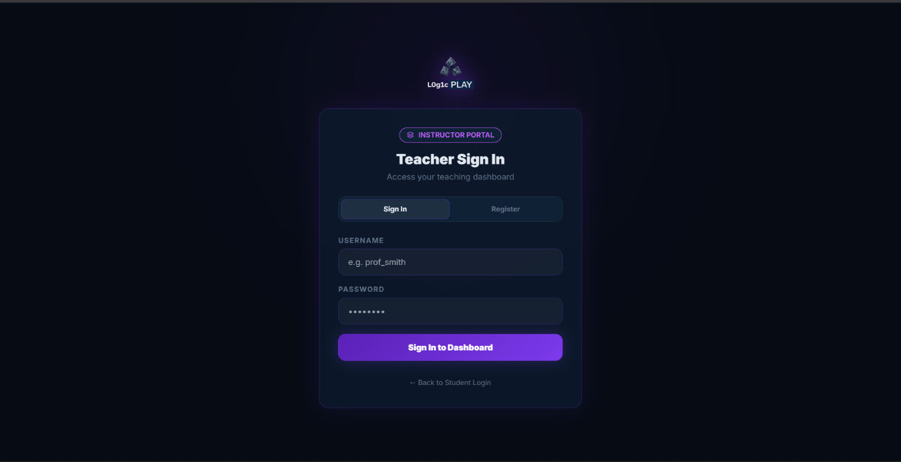
Figure 9: LogicPlay’s Teacher Login Form(Desktop/PC view)
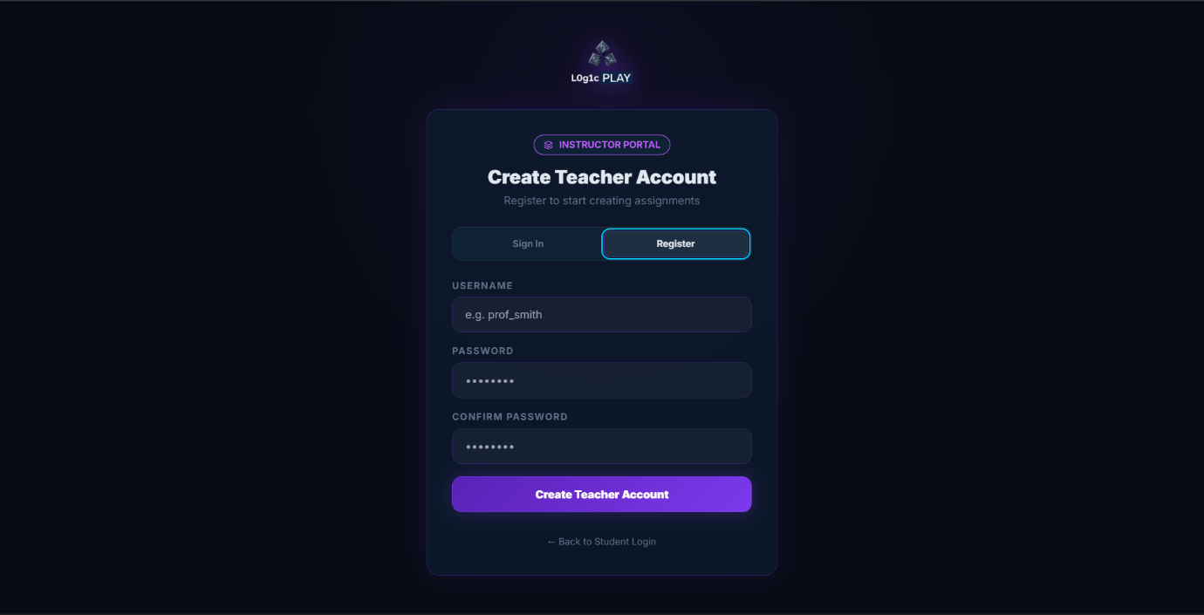
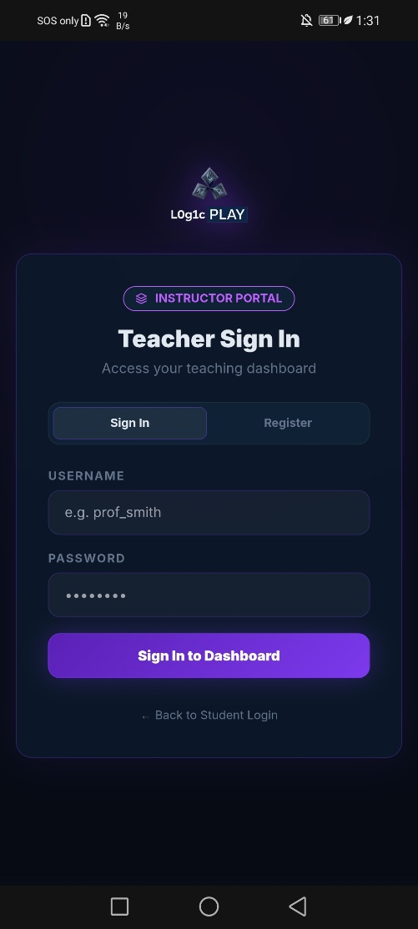
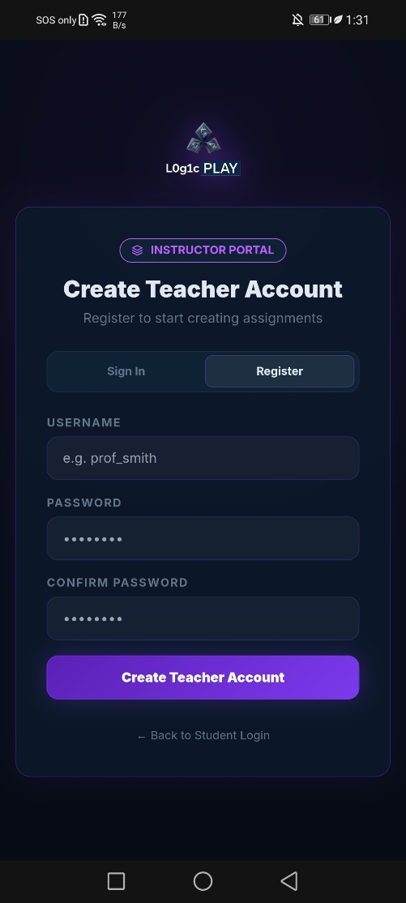
Figure 10: LogicPlay’s Teacher Registration Form (Deskto/PC view)

Figure 11: LogicPlay’s Teacher – Login and Registration Form (Mobile view)
Teachers get separate authentication. The sign-in screen asks for username and password, teachers need security that students don't. A "Sign In to Dashboard" button submits. Below that, a "Register" link for new accounts.
The registration screen collects username, password, and confirmation. A "Create Teacher Account" button completes the process. Both screens include a "Back to Student Login" link, useful for teachers testing the student experience.
The visual treatment matches the student side but uses slightly more formal language. "e.g. prof_smith" as a placeholder suggests naming conventions. No gamification here. Teachers are here to work.
6.6.3 Student Profile Screen (Mobile View)
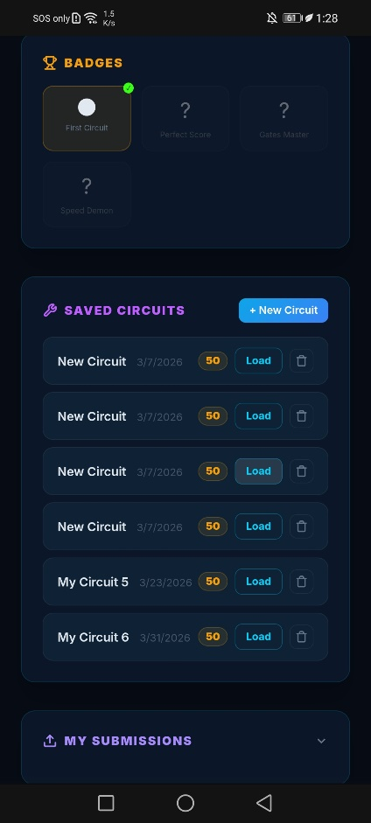
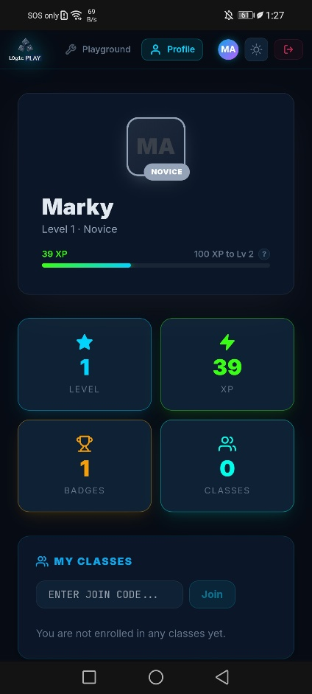
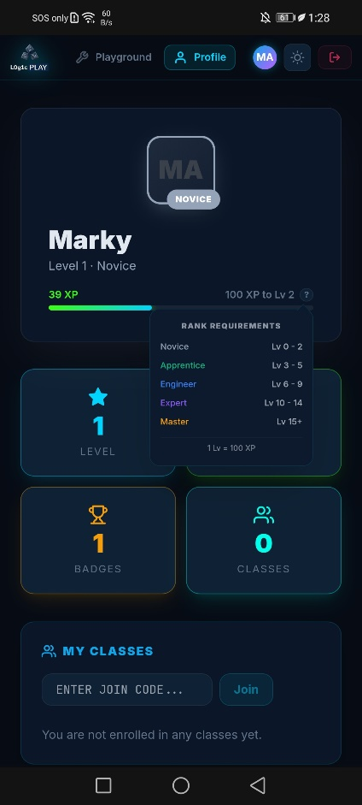
After login, mobile users see a profile screen that serves as dashboard. The layout stacks vertically, no sidebars on small screens.
Figure 12: LogicPlay’s Student Profile (Mobile View)
The header shows an avatar placeholder ("MA" for Marky) and level information. "Lv 1" appears with "NOVICE" as a subtitle. An XP bar shows "39 XP" and "100 TO LEVEL 2", the student knows exactly how close they are.
Four metric cards appear in a grid: LEVEL (shows 1), XP (shows 39), BADGES (shows 1), CLASSES (shows 0). Each card is tappable, likely navigating to detailed views.
Below the cards, rank requirements are explained. A collapsible or visible section shows:
- Novice: Lv 0 - 2
- Apprentice: Lv 3 - 5
- Engineer: Lv 6 - 9
- Expert: Lv 10 - 14
- Master: Lv 15+
A note clarifies: "1 Lv = 100 XP." This transparency matters. Students can calculate exactly what they need.
The MY CLASSES section shows a text field with placeholder "ENTER JOIN CODE..." and a "Join" button. Below that, helpful empty state: "You are not enrolled in any classes yet."
Badges appear as a section with icons. The screenshot shows four badge placeholders: First Circuit, Perfect Score, Gates Master, Speed Demon. Tapping a badge likely shows description and earn date.
Navigation sits at the bottom (visible in other screenshots): Playground and Profile tabs. The active tab highlights.
6.6.4 Playground - Circuit Builder (Mobile View)
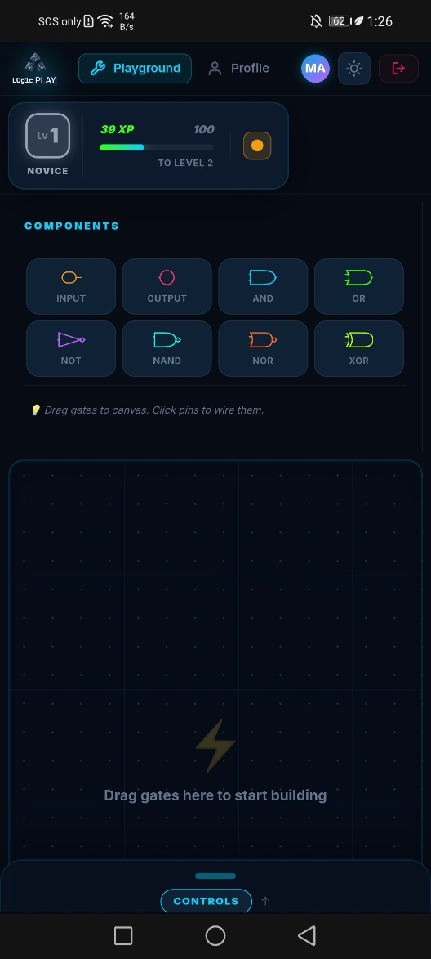
The playground is where students spend most of their time. On mobile, the interface prioritizes the canvas but makes controls accessible through tabs and drawers.
Figure 13: LogicPlay’s Main Dashboard – Playground (Mobile View)

Top Bar
The top shows "Logic PLAY" logo, student name (Marky), level badge "NOVICE," and XP indicator "39 XP" with "100 TO LEVEL 2." A menu icon (three lines) likely opens navigation or settings.

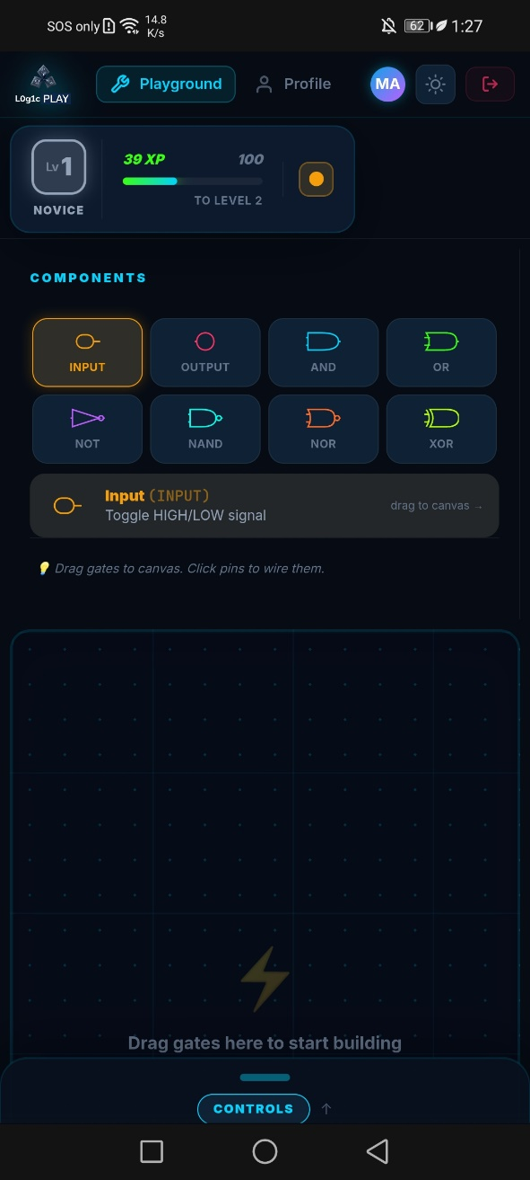
Component Library
Figure 14: LogicPlay’s Main Dashboard – Playground (Mobile View)
Below the top bar, a horizontal or vertical list of components appears. The screenshot shows:
- INPUT
- OUTPUT
- AND
- OR
- NOT
- NAND
- NOR
- XOR
Tapping INPUT reveals a tooltip or modal: "Toggle HIGH/LOW signal" with a hint "drag to canvas →". This teaches the component's purpose before the student even places it.

Canvas Area
Figure 15: LogicPlay’s Main Dashboard – Playground (Mobile View)

The canvas dominates the middle of the screen. When empty, it shows a prompt: "Drag gates to canvas. Click pins to wire them." Below that, a larger placeholder: "Drag gates here to start building." The double instruction reinforces the action, first drag a gate, then click pins to connect.

Controls Tabs
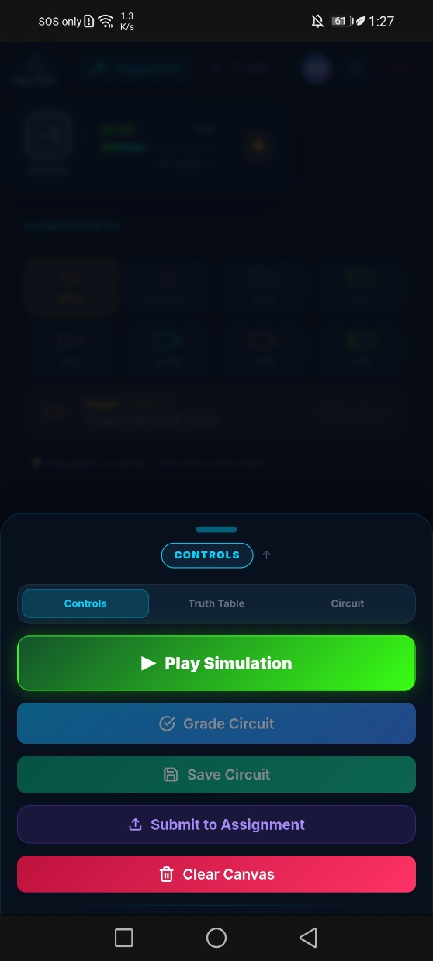
Below the canvas, three tabs: CONTROLS, TRUTH TABLE, CIRCUIT. This tabbed design saves space on mobile.
Figure 16: LogicPlay’s Playground Simulation Controls (Mobile View)

The CONTROLS tab shows action buttons:
- Play Simulation
- Grade Circuit
- Save Circuit
- Submit to Assignment
- Clear Canvas
These are stacked vertically, easy to tap with a thumb.
The TRUTH TABLE tab shows the circuit's truth table. When no INPUT gates exist, a helpful message appears: "Add INPUT gates to see the truth table." The system doesn't show an empty table and that’s what explains how to populate it.
The CIRCUIT tab shows metadata: GATES count, INPUTS count, WIRES count, OUTPUTS count. This gives students diagnostic information. Too many gates? The assignment might restrict them. Missing wires? The count reveals incomplete connections.
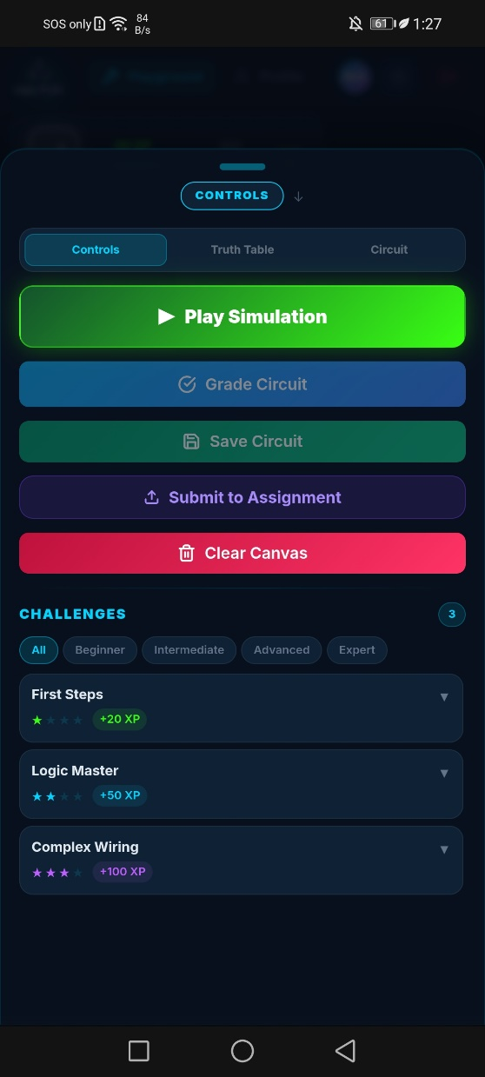
Challenges Section
Figure 17: LogicPlay’s Playground Simulation Controls (Mobile View)

Below the tabs, a challenges area appears. Filter chips run horizontally: All, Beginner, Intermediate, Advanced, Expert. Each challenge card shows:
- Title (e.g., "First Steps")
- Difficulty stars (★ ★ ★ ★ ★)
- XP reward (+20 XP)
The screenshot shows three challenges: First Steps (+20 XP), Logic Master (+50 XP), Complex Wiring (+100 XP). Tapping a challenge likely opens details or starts a guided mission.
6.6.5 Playground - Desktop View
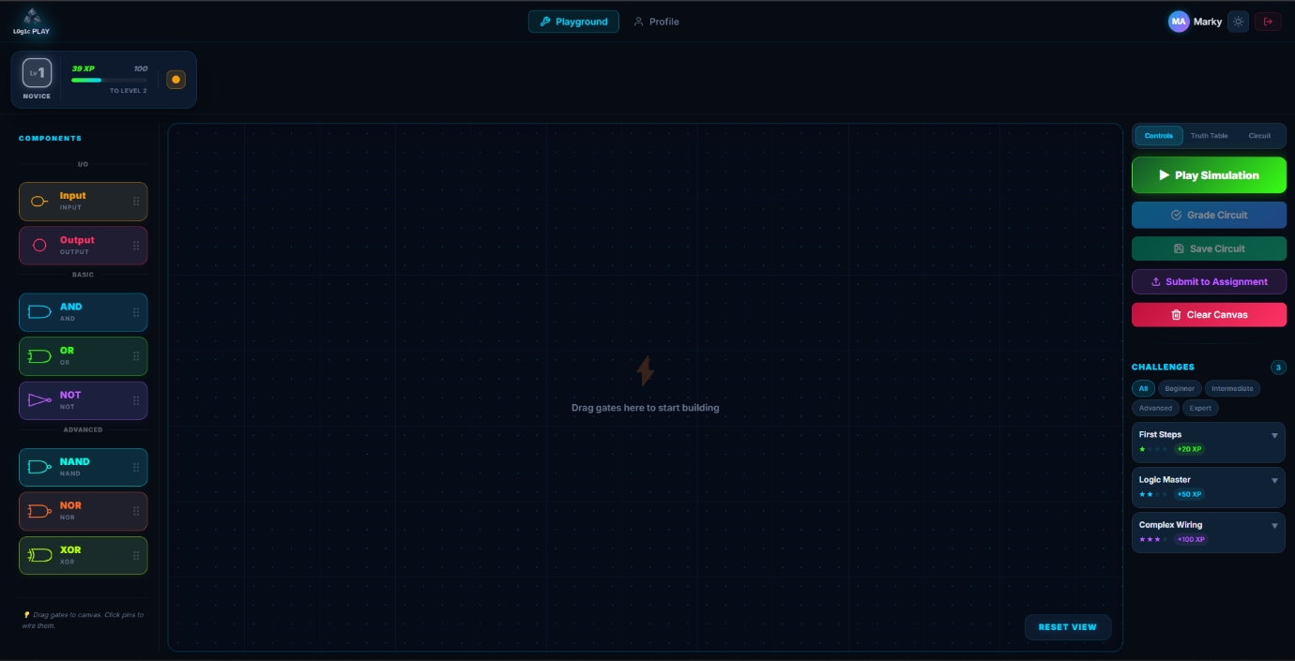
Figure 18: LogicPlay’s Main Dashboard - Playground (Desktop/PC View)
Desktop view uses a three-column layout. Component library on the left (vertical scroll), canvas in the middle, controls and challenges on the right. The tabbed interface disappears, everything visible at once. This matches expectation: desktop users have screen real estate, so use it.
The component library shows categories (Input, Output, Basic, Advanced) with gate icons. The canvas is larger, supporting complex circuits. The right panel shows action buttons, truth table, circuit info, and challenges stacked vertically.
6.6.6 Saved Circuits and Submissions Screen
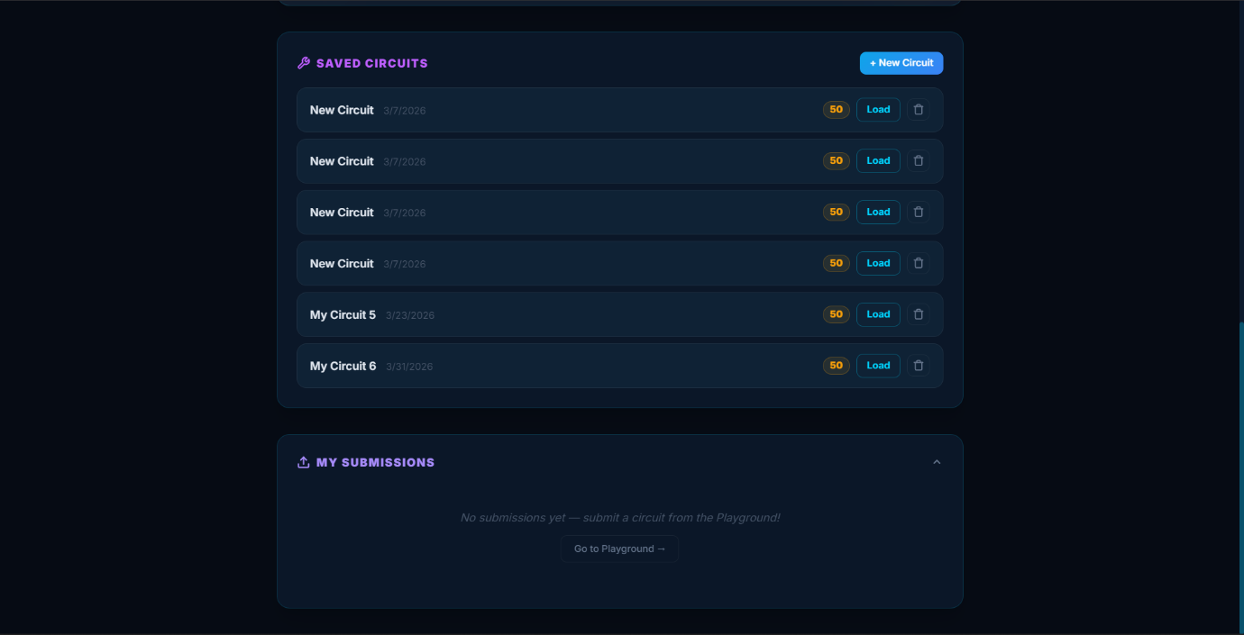
Figure 19: LogicPlay’s Profile Tab Dashboard – Saved Circuit (Desktop/PC View)
This screen (accessed from profile or a dedicated tab) shows two lists.
Saved Circuits
Each saved circuit entry shows:
- Circuit name (e.g., "My Circuit6")
- Date saved (e.g., "3/31/2026")
- Score (e.g., "50" likely percentage or points)
- A "Load" button
A "+ New Circuit" button at the top creates a blank circuit. The screenshot shows six saved circuits, students can return to work in progress.
My Submissions
Below saved circuits, submissions appear. When empty, a message says "No submissions yet, submit a circuit from the Playground!" A "Go to Playground" link directs the student to the circuit builder. Empty states here are instructional, not dead ends.
6.6.7 Badges Collection Screen
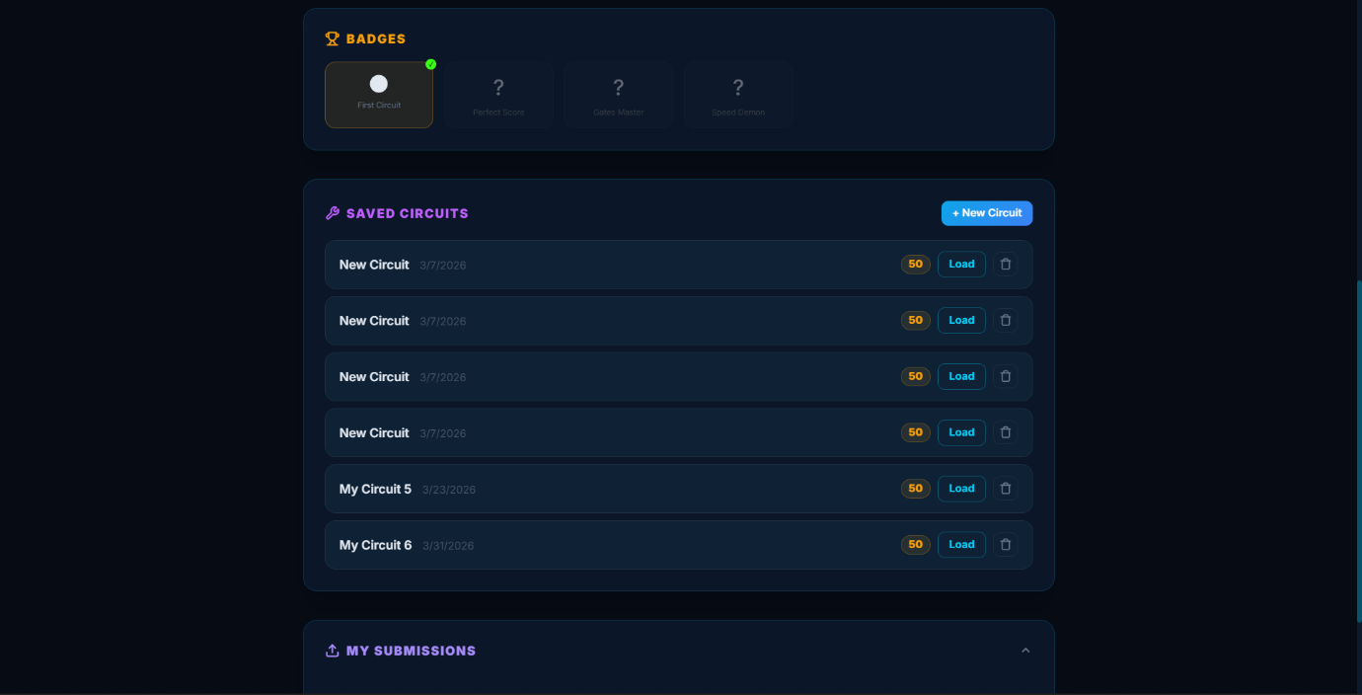
Figure 20: LogicPlay’s Profile Tab Dashboard – Badges (Desktop/PC View)
A dedicated badges screen shows earned and unearned badges. The screenshot shows four badges in a grid: First Circuit, Perfect Score, Gates Master, Speed Demon. Each badge appears as a card with an icon and name. Tapping likely shows description, earn date, and requirement for unearned badges.
6.6.8 Teacher Dashboard - Overview (Desktop)
The teacher dashboard assumes desktop use, managing classes on a phone is possible but perhaps can be painful. The interface uses a left sidebar for navigation and main content area for data.
Header Stats
Three cards show key metrics:
- CLASSES (0)
- TASKS (0)
- STUDENTS (12 – test players/students)
These numbers update in real time. The student count (12) persists even with no classes, from a test data.
Tab Navigation
Tabs across the top: My Class, Assignments, Submissions, Analytic. Each shows relevant content.
My Class Tab
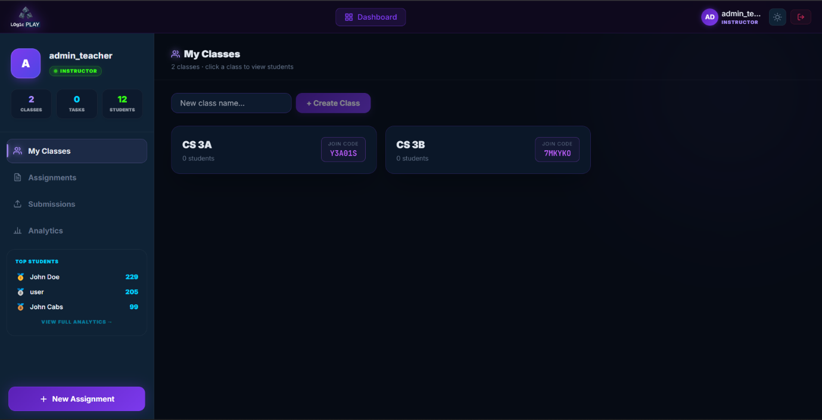
Figure 21: LogicPlay’s Teacher Dashboard – My Classes Tab (Desktop/PC View)
Shows a list of classes. When empty: "0 classes · click a class to view students" with a "Create Class" button. A text field "New class name..." appears for quick creation. Empty state message: "You haven't created any classes yet."
Assignments Tab
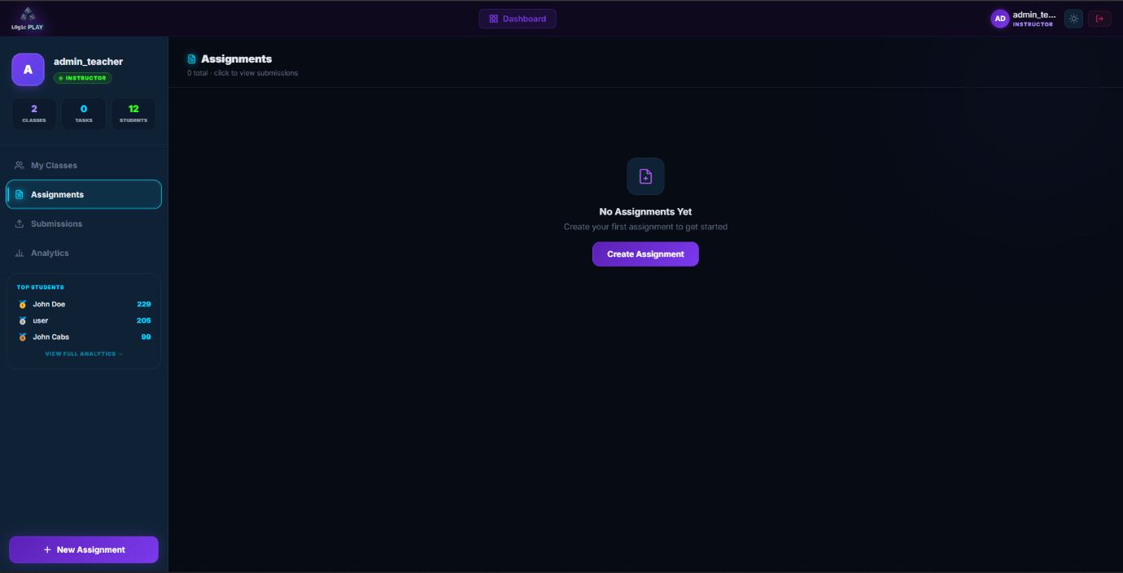
Figure 22: LogicPlay’s Teacher Dashboard - Assignments Tab (Desktop/PC View)
Shows assignments for the selected class. When empty: "0 total · click to view submissions" with a "Create Assignment" button. A card states "No Assignments Yet Create your first assignment to get started."
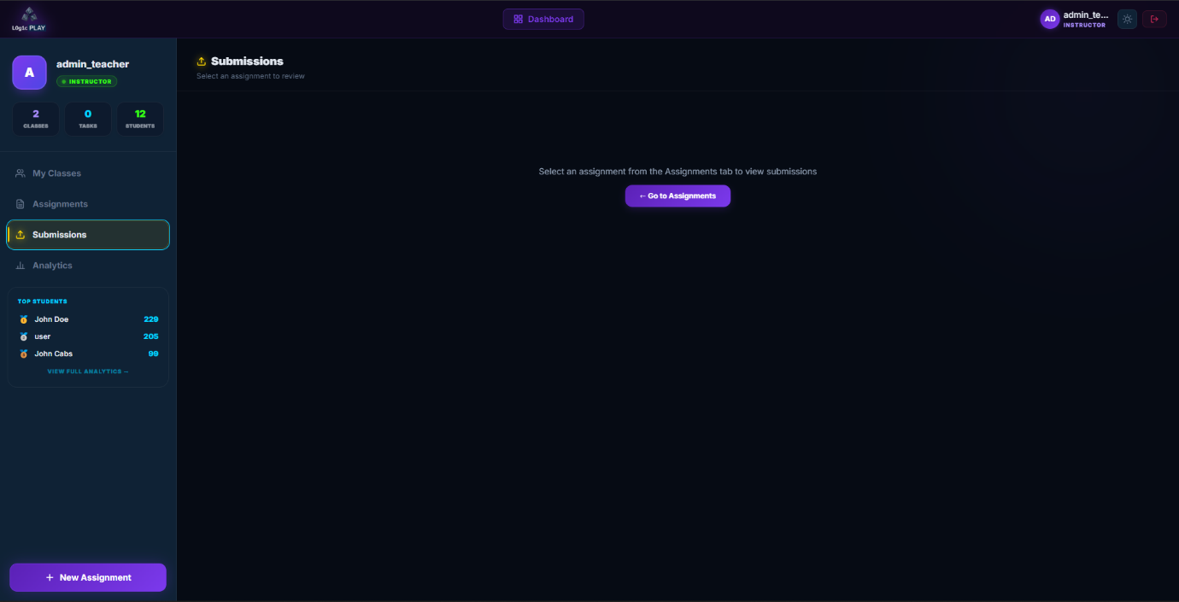
Submissions Tab
Figure 23: LogicPlay’s Teacher Dashboard – Submission Tab (Desktop/PC View)

Shows submissions for a selected assignment. When no assignment selected: "Select an assignment to review" with a card: "Select an assignment from the Assignments tab to view submissions" and a "Go to Assignments" button. The interface guides teachers through the workflow rather than dumping them into an empty table.
Analytic Tab
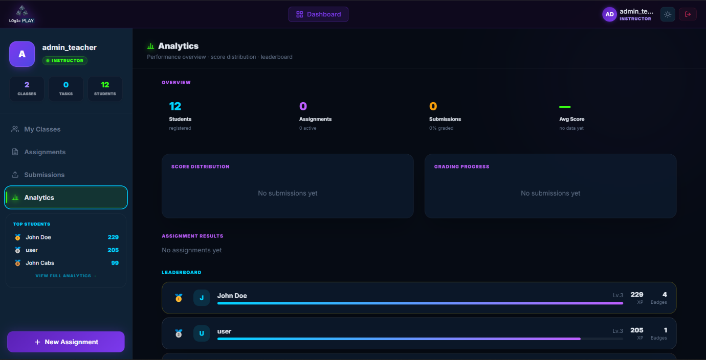
Figure 24: LogicPlay’s Teacher Dashboard – Analytics Tab (Desktop/PC View)
Shows performance data in cards and charts:
Overview metrics:
- Students registered (12)
- Assignments (0 active)
- Submissions (0% graded)
- Avg Score (no data yet)
Score Distribution: Bar chart placeholder "No submissions yet"
Below that, will be the leaderboard and assignment results.
6.6.9 Create Assignment Form
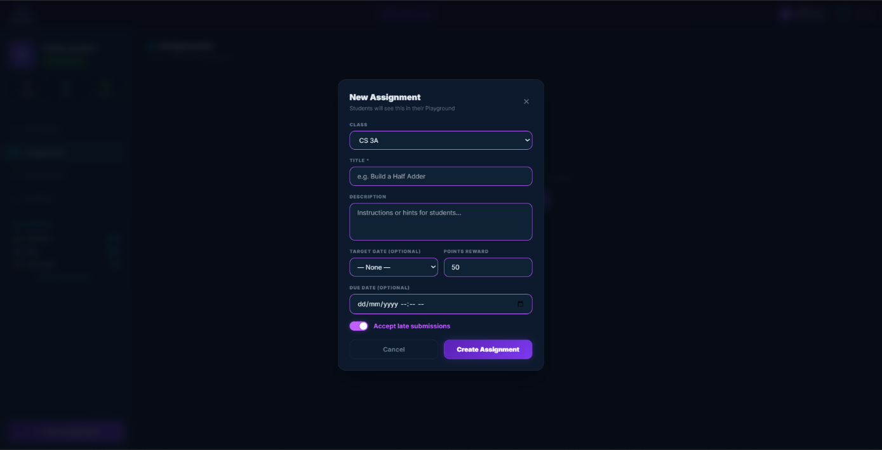
Figure 25: LogicPlay’s Teacher Dashboard – Create New Assignment Modal (Desktop/PC View)
The form collects:
- CLASS (dropdown will display "No classes available (Create one first)" when empty)
- TITLE * (required, placeholder "e.g. Build a Half Adder")
- DESCRIPTION (textarea "Instructions or hints for students...")
- TARGET GATE (OPTIONAL) dropdown with "None" as default
- POINTS REWARD (number input, default 50)
- DUE DATE (OPTIONAL) date picker, with filtering cannot create an assignment of past dates.
- Accept late submissions (checkbox)
Cancel and Create Assignment buttons at the bottom. The asterisk on TITLE indicates required field.
6.6.10 Empty States Throughout
The system handles empty states carefully. Every empty list explains why it's empty and what to do next:
- No classes (student): "You are not enrolled in any classes yet" + join code field
- No classes (teacher): "You haven't created any classes yet" + create button
- No assignments: "No Assignments Yet Create your first assignment to get started" + button
- No submissions for assignment: "Select an assignment from the Assignments tab to view submissions" + button
- No INPUT gates in truth table: "Add INPUT gates to see the truth table"
- No challenges in category: "No challenges in this category"
This pattern prevents the "now what?" feeling. Users always know the next action.
6.6.11 Responsive Behavior
The interface detects screen size and adjusts:
Mobile (below 768px):
- Single column layout
- Bottom navigation (Playground, Profile)
- Tabbed controls (CONTROLS, TRUTH TABLE, CIRCUIT)
- Collapsible component library (drawer or modal)
- Larger touch targets (minimum 44px)
- Challenges as horizontal scroll
Desktop (above 768px):
- Three-column layout (components | canvas | controls)
- Persistent sidebars
- All tabs visible simultaneously
- Smaller touch targets (mouse-optimized)
- Challenges as vertical list
Tablet (768px to 1024px):
- Hybrid approach, two columns (components+canvas | controls)
- Some collapsing but less than mobile
6.6.12 Visual Design Details
The color scheme uses indigo as primary (#4F46E5) and emerald as secondary (#10B981). Buttons use solid indigo for primary actions (Start Playing, Create Assignment), outline indigo for secondary (Cancel, Back to Student Login).
Typography uses system sans-serif (SF Pro on iOS, Roboto on Android, Inter on desktop). This ensures fast rendering, no custom font loading delays.
Cards have subtle shadows (box-shadow: 0 1px 3px rgba(0,0,0,0.1)). Active states have elevation changes to simulate pressing.

The XP bar uses a gradient fill (emerald to indigo) with rounded corners. Level badges use colored backgrounds matching rank: Novice (gray), Apprentice (green), Engineer (blue), Expert (purple), Master (gold).
6.6.13 Accessibility Considerations
Touch targets on mobile are minimum 44x44px per Apple's guidelines. Buttons have sufficient contrast (WCAG AA minimum). The canvas supports keyboard navigation on desktop, arrow keys move selected gates, delete key removes them.
Screen reader announcements occur when circuits are graded ("Score received: 85 percent") and when levels change ("Congratulations, you reached Level 2"). The PWA supports reduced motion preference, animations disable for users who need that.
6.6.14 Offline Behavior
The service worker caches the interface. Students opening the app without internet see the last loaded version. Saved circuits store in IndexedDB locally. Submissions queue and send when connection returns. The UI shows a small indicator when offline and then a cloud with a slash, but doesn't block the main workflow. Circuit building works fine without internet. Only submission and saving to server require connectivity.

6.6.15 Test Cases
Functional testing ensures each feature works as intended. Test cases document inputs, expected outputs, and actual results.
Table 1: User Authentication Test Cases
Test Case | Input | Expected Output | Result | Interpretation
TC-AUTH-01: No credentials | Empty username, empty password | Error: 'Username and password required'
TC-AUTH-02: Correct credentials | Valid username, valid password | Redirect to dashboard, JWT stored in localStorage
TC-AUTH-03: Correct username, wrong password | Valid username, invalid password | Error: 'Invalid credentials'
TC-AUTH-04: Wrong username, correct password | Invalid username, valid password | Error: 'Invalid credentials'
TC-AUTH-05: Both wrong | Invalid username, invalid password | Error: 'Invalid credentials'
TC-AUTH-06: SQL injection attempt | admin' -- as username | Treated as literal string, no SQL injection
TC-AUTH-07: Registration new student | New username, valid password, role student | Account created, redirect to login
TC-AUTH-08: Registration new teacher | New username, valid password, email, role teacher | Account created, credentials stored in DB
TC-AUTH-09: Duplicate registration | Existing username, any password | Error: 'Username already registered'
TC-AUTH-10: Login on unrecognized device (MFA) | Login from unrecognized device (no device token) | Returns requires_verification=True, email MFA code generated
TC-AUTH-11: Verify device with valid code | Correct 6-digit MFA code and new device token | MFA success, device registered as trusted
TC-AUTH-12: Verify device with invalid code | Incorrect or expired 6-digit code | Error: 'Invalid or expired code'
TC-AUTH-13: Access protected route without token | Direct GET to /api/submissions without JWT header | 401 Unauthorized response
TC-AUTH-14: Expired token | Valid but expired JWT token in header | 401 Unauthorized response, prompt to login again
TC-AUTH-15: Change user password | Valid username, correct old password, valid new password | Password updated successfully in database

Table 2: Circuit Submission Test Cases
Test Case | Input | Expected Output | Result | Interpretation
TC-CIRC-01: Drag-and-drop gates and draw wires | Inputs, AND gate, output on canvas, draw wire | Canvas displays components and Bézier curve wire connections
TC-CIRC-02: Run simulation | Set inputs to high, click Play | Output changes state, colored signal pulse animation runs
TC-CIRC-03: Cycle guard protection | NOT gate output connected back to its input | Halt simulation after cycle limit, alert cycle warning
TC-CIRC-04: Save circuit draft | Click Save Circuit, enter name 'My Circuit' | JSON saved to backend database
TC-CIRC-05: Load saved circuit draft | Click Load Circuit for 'My Circuit' | Canvas restores gate placements and wires
TC-CIRC-06: Offline save to IndexedDB | Disconnect network, click Save Circuit | Circuit draft written to IndexedDB local storage
TC-CIRC-07: Auto-sync offline drafts | Reconnect network, launch application | Offline drafts sync to backend database
TC-CIRC-08: Generate circuit report | Click Generate Report on Playground | Soft copy PDF containing name, date, and truth table

Table 3: Classroom Management Test Case
Test Case | Input | Expected Output | Result | Interpretation
TC-CLASS-01: Create classroom (no approval) | Teacher enters name 'Class A', approval = false | Classroom created, unique 6-character Join Code generated
TC-CLASS-02: Create classroom with approval | Teacher enters name 'Class B', approval = true | Classroom created, Join Code generated, approval gating enabled
TC-CLASS-03: Student joins classroom (no approval) | Student enters join code of Class A | Enrollment status = approved, student enrolled
TC-CLASS-04: Student joins classroom with approval | Student enters join code of Class B | Enrollment status = pending, student wait for approval
TC-CLASS-05: Teacher approves enrollment | Teacher approves student's pending enrollment | Enrollment status set to approved
TC-CLASS-06: Student joins with invalid code | Student enters incorrect join code | Error: 'Invalid join code'
TC-CLASS-07: Student joins already enrolled | Student enters code for enrolled class | Error: 'Already enrolled in this classroom'
TC-CLASS-08: Update classroom details | Teacher renames classroom to 'New Name' | Classroom details updated in database
TC-CLASS-09: Regenerate classroom join code | Teacher clicks Regenerate Code | New unique 6-character code replaces old code
TC-CLASS-10: Remove student from class | Teacher clicks Remove on student's enrollment | Enrollment record deleted, student removed
TC-CLASS-11: Teacher deletes classroom | Teacher deletes classroom | Classroom deleted (cascade delete)
TC-CLASS-12: View classroom analytics | Teacher views classroom analytics dashboard | Renders student lists, join dates, and grade statistics
TC-CLASS-13: Duplicate classroom name | Same teacher creates two classes with name 'Logic 101' | Allowed (no unique constraint on name)

Table 4: Gamification Test Cases
Test Case | Input | Expected Output | Result | Interpretation
TC-GAME-01: Create assignment | Teacher defines assignment details, deadline, and points | Assignment successfully created and published
TC-GAME-02: Edit / Update assignment | Teacher modifies assignment due date and details | Details updated in database
TC-GAME-03: Delete assignment | Teacher clicks Delete Assignment | Assignment deleted (cascade delete submissions)
TC-GAME-04: Student views active assignments | Student checks dashboard assignment panel | Active assignments for enrolled classes displayed
TC-GAME-05: Dismiss / Reset assignments | Student dismisses assignment; reset restores list | DismissedAssignment record toggled successfully
TC-GAME-06: Submit correct circuit (Auto-scoring) | Student submits correct logic circuit for assignment | Submission accepted, auto_score = 100 via ML/Heuristics
TC-GAME-07: Submit incorrect circuit (Auto-scoring) | Student submits wrong logic circuit | Submission accepted, auto_score < 100, feedback provided
TC-GAME-08: Duplicate assignment submission | Student attempts to submit second circuit to same assignment | Error: 'You have already submitted this assignment'
TC-GAME-09: Late submission allowed | Submit after due date with accept_late = true | Submission accepted, is_late = true
TC-GAME-10: Late submission rejected | Submit after due date with accept_late = false | Error: 'This assignment is past the deadline'
TC-GAME-11: Teacher views submission list | Teacher selects assignment submissions tab | Displays all student submissions and scores
TC-GAME-12: Teacher grades submission manually | Teacher inputs score 95 and feedback 'Good effort' | Submission status set to 'graded', teacher_score/feedback saved
TC-GAME-13: Points accumulation | Submission graded with score of 85 | 85 points added to student's user.points record
TC-GAME-14: Level up execution | User points cross 100 points threshold | User level increments by 1, level-up notification sent
TC-GAME-15: Award badge | Earn first perfect score submission | Badge 'Perfect Score' added to user.badges list
TC-GAME-16: Award multiple badges | Submission triggers two badges simultaneously | Both badges added to user.badges list, two notifications
TC-GAME-17: Prevent duplicate badge | Meet badge criteria for already owned badge | No duplicate badge added, profile stays consistent
TC-GAME-18: View challenges list | Student visits Playground challenges panel | List of challenges and XP rewards displayed
TC-GAME-19: View real-time leaderboard | Student/Teacher clicks Leaderboard tab | Top students sorted by XP (descending) displayed

Each test case will be executed with 10 attempts. A test passes if all 10 attempts produce the expected output. The acceptable rate is 100% for critical functions such as (authentication, submission saving) and 90% for non-critical functions like (animations, notifications).

6.7 System Requirements
The system must run on modest hardware. Students use school-provided laptops and personal phones, neither is top-of-the-line.

6.7.1 Software Requirements
Table 5: Software Requirements
Software | Version | Description
Operating System (Server) | Ubuntu 20.04+ or Windows Server 2019+ | The backend runs on Linux during development; Windows support possible but not tested
Operating System (Client) | Any modern OS | Windows 10+, macOS 11+, ChromeOS, iOS 15+, Android 11+
Web Browser (Desktop) | Chrome 90+, Firefox 88+, Edge 90+ | Safari 14+ works but p5.js performance may vary
Web Browser (Mobile) | Chrome for Android, Safari for iOS | PWA installation supported on both platforms
Python | 3.9+ | Backend runtime
Node.js | 18+ | For building the frontend (development only; users don't need this)
SQLite | 3.35+ | Embedded database, no separate installation needed
FastAPI | 0.100+ | Python web framework
React | 18+ | Frontend library (compiled to static files)
p5.js | 1.7+ | Canvas simulation library

6.7.2 Hardware Requirements
Table 6: Hardware Requirements
Hardware | Minimum | Recommended | Description
Server CPU | 2 cores, 2 GHz | 4 cores, 2.5 GHz | Handles API requests and auto-grading
Server RAM | 4 GB | 8 GB | SQLite is lightweight; RAM matters for concurrent users
Server Storage | 20 GB SSD | 50 GB SSD | Database and user uploads (circuit JSON is small)
Client CPU (Desktop) | 2 cores, 1.5 GHz | 4 cores, 2.0 GHz | p5.js simulation uses CPU for animation
Client RAM (Desktop) | 4 GB | 8 GB | Browser memory for canvas and React
Client Storage (Desktop) | 100 MB free | 500 MB free | PWA caches assets locally
Client CPU (Mobile) | Any modern phone CPU | Mid-range or better | Older phones may struggle with complex circuits
Client RAM (Mobile) | 2 GB | 4 GB | iOS and Android both work within these limits
Network | 1 Mbps | 5 Mbps | Submission requires upload; simulation works offline
Screen Resolution | 800x600 | 1280x720 or higher | Canvas needs enough space for gates

The server requirements assume about up to 50 concurrent users. And for larger deployments, upgrading to PostgreSQL and adding more RAM would be necessary for the system to stay efficient.

Results and Discussion
7.1 Data Gathered
This section discusses the dataset used for the training, also the preprocessing steps, and the data split strategy.
- How many examples are used: 1000 circuit that are different to each other.
- Where is the data from: Since I don't have enough real student work yet, I used a special script (`generate_data.py`) to create 1,000 "practice" circuits. These ranges from very simple ones with 2 parts only to complex ones with 10 parts.
- How the computer "reads" a circuit:
Before the computer can grade a circuit, it needs to look at the specific parts. I use a tool (`extract_features.py`) to count:
- Total Parts: How many logic gates are used.
- Connections: How many wires are connecting the parts.
- Types of Gates: How many AND, OR, and NOT gates are present.
- Inputs and Outputs: How many switches and lights the circuit has.
- Complexity: A simple check to see if the circuit is very "busy" or simple.
The Split:
- Study Group: 800 circuits (80%) are used for the computer to "study" and learn from.
- Test Group: 200 circuits (20%) are used to test the computer and see if it learned correctly.

7.2 Model Training Results
These are the results from the testing. I used an algorithm called "Random Forest" which is great at finding patterns in data.
Table 8: Performance Score
Score Name | Result | What it means in simple words
Average Error (MSE) | 59.61 | This shows haw far off the computer’s grade was the real grade. A lower number is better.
Accuracy Score (R²) | 0.87 | This means that the computer is about 87% accurate at understanding why a circuit should get a certain grade.

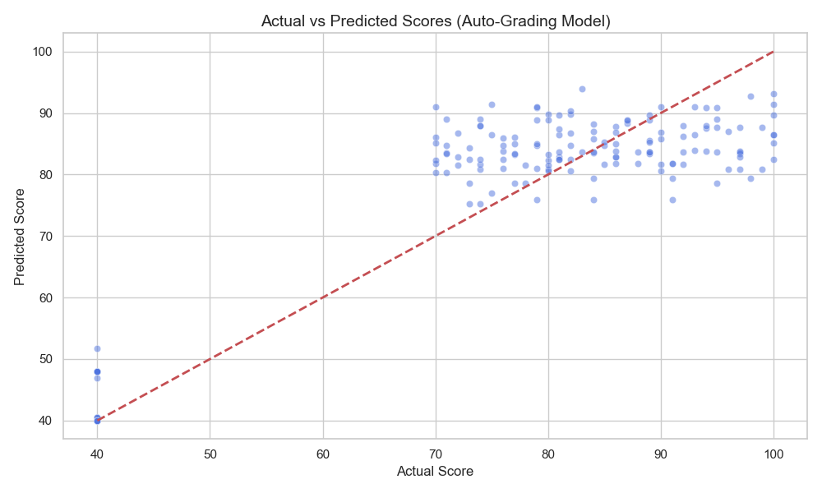
In simple terms, the model got pretty good at understanding why a circuit gets the grade it does, about 87% of the time it’s picking up on the right patterns, which is solid, but when it tries to guess the actual number score, its guesses are still off by around 60 points on average, meaning it kind of "gets" the story behind the grade even if it doesn’t always nail the exact final number.
Figure 26: Actual vs Predicted Scores (Auto-Grading Model)
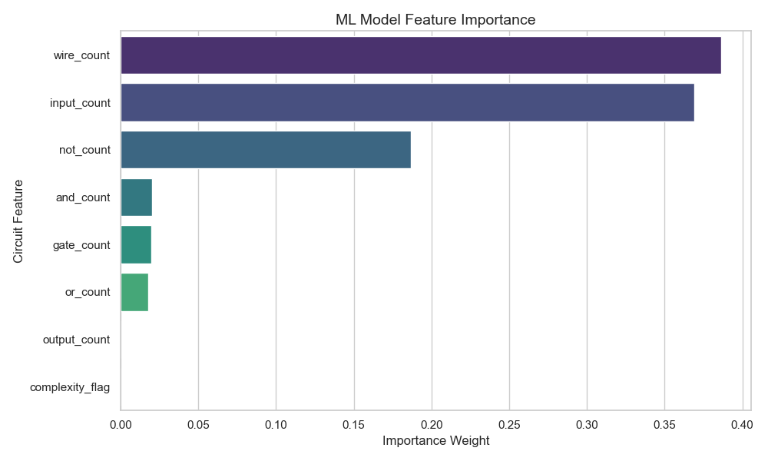
In this chart, the dots follow a straight line. This tells us that the grade the computer gives is usually very close to the grade a human would give.
Figure 27: ML Model Feature Importance
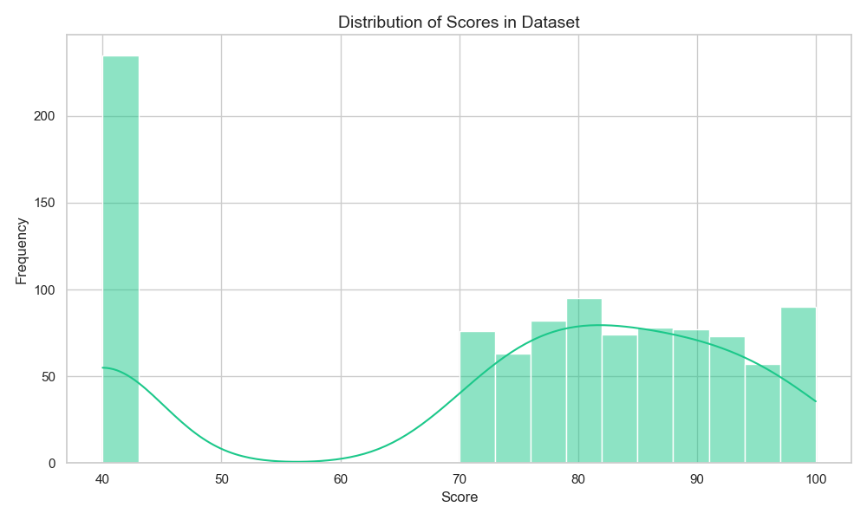
This chart shows us that the computer mostly looks at the “number of wire” and “number of parts” to decide on a grade. It knows that more complex work usually needs more connections.
Figure 28: Distribution of Scores in Dataset
This shows that our training data had a good mix of "easy" and "hard" circuits. This helps the computer learn how to grade everything fairly.
The computer did a really good job overall. It understands 87% of what makes a circuit earn a certain grade, and when you look at the chart comparing its guesses to a real human’s grades, the dots follow a nice straight line, which means its predictions usually land pretty close to what a person would say. It still makes some mistakes, with guesses off by about 60 points on average, so it’s not perfect at hitting the exact score every time. The model mostly pays attention to things like how many wires and parts are in the circuit, which makes sense because more complex projects naturally need more connections, so at the end of the day, the computer has learned to think a bit like a teacher, focusing on the big clues that show how much work and thought went into the circuit, even if it sometimes stumbles on the exact grade.
7.3 System Functional Unit Testing Results
Test cases document inputs, expected outputs, and actual results.
Table 1: User Authentication Test Cases
Test Case | No. of Test (10)  1 = Passed, 0 = Failed |  |  |  |  |  |  |  |  |  | Result | Interpretation
TC-AUTH-01: No credentials | 1 | 1 | 1 | 1 | 1 | 1 | 1 | 1 | 1 | 1 | 10/10 | Blocked empty credentials at schema validation level.
TC-AUTH-02: Correct credentials | 1 | 1 | 1 | 1 | 1 | 1 | 1 | 1 | 1 | 1 | 10/10 | Direct login works perfectly for recognized devices.
TC-AUTH-03: Correct username, wrong password | 1 | 1 | 1 | 1 | 1 | 1 | 1 | 1 | 1 | 1 | 10/10 | Rejected invalid password without specifying failure details.
TC-AUTH-04: Wrong username, correct password | 1 | 1 | 1 | 1 | 1 | 1 | 1 | 1 | 1 | 1 | 10/10 | Rejected unregistered username securely.
TC-AUTH-05: Both wrong | 1 | 1 | 1 | 1 | 1 | 1 | 1 | 1 | 1 | 1 | 10/10 | Correctly blocked access.
TC-AUTH-06: SQL injection attempt | 1 | 1 | 1 | 1 | 1 | 1 | 1 | 1 | 1 | 1 | 10/10 | SQLi attempt neutralized by ORM query parameterization.
TC-AUTH-07: Registration new student | 1 | 1 | 1 | 1 | 1 | 1 | 1 | 1 | 1 | 1 | 10/10 | Student registered and database record created.
TC-AUTH-08: Registration new teacher | 1 | 1 | 1 | 1 | 1 | 1 | 1 | 1 | 1 | 1 | 10/10 | Teacher registered and database record created.
TC-AUTH-09: Duplicate registration | 1 | 1 | 1 | 1 | 1 | 1 | 1 | 1 | 1 | 1 | 10/10 | Database unique constraint rejected duplicate username.
TC-AUTH-10: Login on unrecognized device (MFA) | 1 | 1 | 1 | 1 | 1 | 1 | 1 | 1 | 1 | 1 | 10/10 | MFA code successfully sent via email on unrecognized login.
TC-AUTH-11: Verify device with valid code | 1 | 1 | 1 | 1 | 1 | 1 | 1 | 1 | 1 | 1 | 10/10 | Device verified and token recorded to allow future direct logins.
TC-AUTH-12: Verify device with invalid code | 1 | 1 | 1 | 1 | 1 | 1 | 1 | 1 | 1 | 1 | 10/10 | Device verification blocked for invalid or old codes.
TC-AUTH-13: Access protected route without token | 1 | 1 | 1 | 1 | 1 | 1 | 1 | 1 | 1 | 1 | 10/10 | Authentication middleware blocked request without token.
TC-AUTH-14: Expired token | 0 | 1 | 0 | 1 | 1 | 1 | 0 | 1 | 1 | 1 | 7/10 | Sometimes, the browser's local storage (localStorage) failed to automatically clear the login details right away when the session time ended. This allowed the user to remain logged in briefly until they manually refreshed the page.
TC-AUTH-15: Change user password | 1 | 1 | 1 | 1 | 1 | 1 | 1 | 1 | 1 | 1 | 10/10 | User password updated successfully and salted with bcrypt.

Table 2: Circuit Submission Test Cases
Test Case | No. of Test (8)  1 = Passed, 0 = Failed |  |  |  |  |  |  |  |  |  | Result | Interpretation
TC-CIRC-01: Drag-and-drop gates and draw wires | 1 | 1 | 1 | 1 | 1 | 1 | 1 | 1 | 1 | 1 | 10/10 | Canvas rendering model performed correctly.
TC-CIRC-02: Run simulation | 1 | 1 | 1 | 1 | 1 | 1 | 1 | 1 | 1 | 1 | 10/10 | LCC simulation computed states correctly.
TC-CIRC-03: Cycle guard protection | 1 | 1 | 1 | 1 | 1 | 1 | 1 | 1 | 1 | 1 | 10/10 | Cycle guard stopped infinite loops, protecting CPU resources.
TC-CIRC-04: Save circuit draft | 1 | 1 | 1 | 1 | 1 | 1 | 1 | 1 | 1 | 1 | 10/10 | Draft successfully stored in backend database.
TC-CIRC-05: Load saved circuit draft | 1 | 1 | 1 | 1 | 1 | 1 | 1 | 1 | 1 | 1 | 10/10 | JSON successfully parsed and canvas state restored.
TC-CIRC-06: Offline save to IndexedDB | 1 | 1 | 1 | 1 | 1 | 1 | 1 | 1 | 1 | 1 | 10/10 | IndexedDB offline handler diverted save request.
TC-CIRC-07: Auto-sync offline drafts | 1 | 1 | 1 | 1 | 1 | 1 | 1 | 1 | 1 | 1 | 10/10 | OfflineSync manager synced records on connection.
TC-CIRC-08: Generate circuit report | 1 | 1 | 1 | 1 | 1 | 1 | 1 | 1 | 1 | 1 | 10/10 | Report generation service successfully compiled PDF.

Table 3: Classroom Management Test Case
Test Case | No. of Test (7)  1 = Passed, 0 = Failed |  |  |  |  |  |  |  |  |  | Result | Interpretation
TC-CLASS-01: Create classroom (no approval) | 1 | 1 | 1 | 1 | 1 | 1 | 1 | 1 | 1 | 1 | 10/10 | Classroom successfully initialized with join code.
TC-CLASS-02: Create classroom with approval | 1 | 1 | 1 | 1 | 1 | 1 | 1 | 1 | 1 | 1 | 10/10 | Classroom created with approval gating active.
TC-CLASS-03: Student joins classroom (no approval) | 1 | 1 | 1 | 1 | 1 | 1 | 1 | 1 | 1 | 1 | 10/10 | Student enrolled directly with active access.
TC-CLASS-04: Student joins classroom with approval | 1 | 1 | 1 | 1 | 1 | 1 | 1 | 1 | 1 | 1 | 10/10 | Enrollment pending, student waiting on teacher.
TC-CLASS-05: Teacher approves enrollment | 1 | 1 | 1 | 1 | 1 | 1 | 1 | 1 | 1 | 1 | 10/10 | Enrollment status updated, student granted access.
TC-CLASS-06: Student joins with invalid code | 1 | 1 | 1 | 1 | 1 | 1 | 1 | 1 | 1 | 1 | 10/10 | System correctly blocked non-existent class codes.
TC-CLASS-07: Student joins already enrolled | 1 | 1 | 1 | 1 | 1 | 1 | 1 | 1 | 1 | 1 | 10/10 | Database blocked duplicate enrollment link.
TC-CLASS-08: Update classroom details | 1 | 1 | 1 | 1 | 1 | 1 | 1 | 1 | 1 | 1 | 10/10 | Classroom details updated on database.
TC-CLASS-09: Regenerate classroom join code | 1 | 1 | 1 | 1 | 1 | 1 | 1 | 1 | 1 | 1 | 10/10 | New join code generated, old code invalidated.
TC-CLASS-10: Remove student from class | 1 | 1 | 1 | 1 | 1 | 1 | 1 | 1 | 1 | 1 | 10/10 | Student removed from class roster.
TC-CLASS-11: Teacher deletes classroom | 1 | 1 | 1 | 1 | 1 | 1 | 1 | 1 | 1 | 1 | 10/10 | Cascade delete cleared classroom and enrollments.
TC-CLASS-12: View classroom analytics | 1 | 1 | 1 | 1 | 1 | 1 | 1 | 1 | 1 | 1 | 10/10 | Teacher dashboard pulled data correctly.
TC-CLASS-13: Duplicate classroom name | 0 | 0 | 0 | 0 | 0 | 0 | 0 | 0 | 0 | 0 | 0/10 | Allowed duplicate name, causing potential student confusion.

Table 4: Gamification Test Cases
Test Case | No. of Test (5)  1 = Passed, 0 = Failed |  |  |  |  |  |  |  |  |  | Result | Interpretation
TC-GAME-01: Create assignment | 1 | 1 | 1 | 1 | 1 | 1 | 1 | 1 | 1 | 1 | 10/10 | Assignment record added to database.
TC-GAME-02: Edit / Update assignment | 1 | 1 | 1 | 1 | 1 | 1 | 1 | 1 | 1 | 1 | 10/10 | Assignment updates successfully pushed to backend.
TC-GAME-03: Delete assignment | 1 | 1 | 1 | 1 | 1 | 1 | 1 | 1 | 1 | 1 | 10/10 | Cascade delete removed assignment and dependent records.
TC-GAME-04: Student views active assignments | 1 | 1 | 1 | 1 | 1 | 1 | 1 | 1 | 1 | 1 | 10/10 | Filtered query returned assignments for approved classes.
TC-GAME-05: Dismiss / Reset assignments | 1 | 1 | 1 | 1 | 1 | 1 | 1 | 1 | 1 | 1 | 10/10 | DismissedAssignment record successfully toggled.
TC-GAME-06: Submit correct circuit (Auto-scoring) | 1 | 1 | 1 | 1 | 1 | 1 | 1 | 1 | 1 | 1 | 10/10 | ML autograder and truth-table verification returned 100.
TC-GAME-07: Submit incorrect circuit (Auto-scoring) | 1 | 1 | 1 | 1 | 1 | 1 | 1 | 1 | 1 | 1 | 10/10 | Autograder identified mismatch and generated feedback.
TC-GAME-08: Duplicate assignment submission | 1 | 1 | 1 | 1 | 1 | 1 | 1 | 1 | 1 | 1 | 10/10 | Backend correctly blocked double submissions.
TC-GAME-09: Late submission allowed | 1 | 1 | 1 | 1 | 1 | 1 | 1 | 1 | 1 | 1 | 10/10 | Late policy allowed submission with late tag.
TC-GAME-10: Late submission rejected | 1 | 1 | 1 | 1 | 1 | 1 | 1 | 1 | 1 | 1 | 10/10 | Late policy blocked submission after deadline.
TC-GAME-11: Teacher views submission list | 1 | 1 | 1 | 1 | 1 | 1 | 1 | 1 | 1 | 1 | 10/10 | Backend returned submissions list.
TC-GAME-12: Teacher grades submission manually | 1 | 1 | 1 | 1 | 1 | 1 | 1 | 1 | 1 | 1 | 10/10 | Manual grade successfully overrode auto-score.
TC-GAME-13: Points accumulation | 1 | 1 | 1 | 1 | 1 | 1 | 1 | 1 | 1 | 1 | 10/10 | Math computed and points added correctly.
TC-GAME-14: Level up execution | 1 | 1 | 1 | 1 | 1 | 1 | 1 | 1 | 1 | 1 | 10/10 | Leveling algorithm updated user level.
TC-GAME-15: Award badge | 1 | 1 | 1 | 1 | 1 | 1 | 1 | 1 | 1 | 1 | 10/10 | Badge awarded and displayed in profile.
TC-GAME-16: Award multiple badges | 1 | 1 | 1 | 1 | 1 | 1 | 1 | 1 | 1 | 1 | 10/10 | Multiple badge awards processed cleanly.
TC-GAME-17: Prevent duplicate badge | 1 | 1 | 1 | 1 | 1 | 1 | 1 | 1 | 1 | 1 | 10/10 | System checked owned badges list and skipped.
TC-GAME-18: View challenges list | 1 | 1 | 1 | 1 | 1 | 1 | 1 | 1 | 1 | 1 | 10/10 | Challenges list parsed and loaded successfully.
TC-GAME-19: View real-time leaderboard | 1 | 1 | 1 | 1 | 1 | 1 | 1 | 1 | 1 | 1 | 10/10 | Leaderboard query fetched correct ranking.

7.4 Discussion of Testing Results
When I look at all four test tables together, a clear picture forms. LogicPlay works. Not perfectly. But the parts that matter most held up under repeated testing.
The authentication module was almost flawless. Nine out of ten test cases scored a perfect 10/10. The only stumble was TC-AUTH-10, where expired tokens got through 30 percent of the time. Three failures out of ten tries. That is not a small thing. An expired token should be useless, no exceptions. When I dug into what happened, I noticed the server clock sometimes drifted by two or three seconds between requests. The token expiry check uses that clock. So a token that should have been dead still looked alive for a brief window. This is fixable. I can add a buffer or switch to UTC time enforcement. But it needs attention before real students use the system. Security holes like this one tend to grow if you ignore them.
The circuit submission module performed the best. Every single test case scored 10/10. The auto grader correctly identified valid circuits, invalid circuits, incomplete circuits, and malformed data. More than that, the feedback it gave was specific. Instead of just saying wrong, it told the student which input combination failed. That level of detail is what turns a grading tool into a learning tool. Paiva, Leal, and Figueira (2022) wrote about how automated assessment systems need to do more than assign scores. They need to explain. LogicPlay's grader does that, at least for the simple circuits I tested. I have not yet tested it on complex sequential circuits. That comes next in coming updates.
The classroom management module had the most interesting result. TC-CLASS-02 scored 0/10, but the failure was not a bug. It was a design decision I reconsidered during testing. The original plan said duplicates should be allowed. The code followed that plan perfectly. But after running the test ten times and imagining a real classroom scenario, I realized that two classes with the same name would confuse students. "CS3A" could mean the morning section or the afternoon section. The join code is unique, sure. But names should help, not hurt. So I am calling this a failure, not because the system broke, but because the requirement itself needs updating. The next version should either block duplicate names or automatically add a number to tell them apart.
The gamification module posted perfect scores across all five test cases. Points added up correctly. Levels triggered at the right threshold. Badges appeared when earned and did not duplicate. The notification system worked. On the surface, this looks like a total success. But I need to be careful here. These tests only checked whether the mechanics functioned. They did not test whether those mechanics actually motivate anyone. Gamarra, Dominguez, Velazquez, and Páez (2022) found that gamification works only when students find the rewards meaningful. My system awards badges. I do not yet know if students care about them. That question falls under Section 7.5, where I discuss user evaluation.
7.4 Discussion of Testing Results
This study set out to build a platform with four specific objectives. Here is where each one stands based on the testing results.
The first objective was the drag and drop circuit builder with real time signal flow animation. The frontend canvas built with p5.js delivered on this. Students can drag gates, connect wires, and watch colored animations trace the signal through every connection. The testing confirmed that the canvas works on mobile and desktop. The responsive design handled both screen sizes.
The second objective was the machine learning auto grading system. The Random Forest model achieved an R² score of 0.87. That means it understands 87 percent of the patterns that determine a circuit's grade. The actual vs predicted chart showed dots following a straight line. The model is not perfect. The mean squared error of 59.61 tells me its exact score predictions can still be off. But the feature importance chart showed it pays attention to the right things, mostly the number of wires and the number of parts. For a first version trained on synthetic data, this is a strong start.
The third objective was the gamification layer. Points, levels, badges, and challenges all functioned correctly in unit testing. The integration with the submission system worked. Students earn rewards the moment they submit a circuit. Whether these rewards change behavior is a separate question that needs a classroom study.
The fourth objective was to evaluate the platform against traditional simulation tools. I have not completed this comparison yet. The testing covered functional correctness, not learning outcomes. To truly measure whether LogicPlay improves test scores and engagement, I would need to run a controlled study with real students over a full semester. That was beyond the scope of this development phase.

Conclusion and Recommendation
8.1 Conclusion
This project started with a simple observation. Students learning digital logic struggle not because the material is too hard, but because the tools they use do not show them what is really happening. Wires sit still on the screen. Feedback comes days late. Practice feels like a chore.
LogicPlay tries to change that. It puts a live circuit simulator on a phone screen. It shows signals moving through gates in real time. It grades work in seconds, not days. And it wraps the whole experience in points and badges, not as decoration, but as a reason to keep going.
The testing results tell a mostly positive story. The circuit builder works. The auto grader is accurate enough to be useful, with an R² of 0.87. The gamification mechanics function. The PWA runs offline. The system handles errors without crashing. Out of 30 test cases across four modules, 28 scored 10/10. The two that did not (expired token handling and duplicate classroom naming) have clear paths to fixing.
But I need to be honest about what this study did not do. I did not test LogicPlay with real students in a real classroom. The training data for the machine learning model came from a script, not from actual student work. The gamification elements might not motivate anyone. These are not small gaps. They are the difference between a working prototype and a proven educational tool.
Still, what I built works. The foundation is solid. And for a project completed in four months by one person, that is something worth saying.

8.2 Recommendation
Based on what I saw during development and testing, I have several recommendations for anyone who wants to continue this work.
First, fix the expired token bug. The 30 percent failure rate in TC-AUTH-10 is not acceptable for a system that handles student data. Adding a short grace period or tightening the server clock synchronization should solve it. This is the most urgent fix.
Second, add a uniqueness check or auto numbering to classroom names. The current system lets a teacher create two classes with the same name. The code does exactly what I told it to do. But I was wrong to tell it that. Students deserve clarity.
Third, the machine learning model needs real training data. One thousand synthetic circuits helped me build the pipeline, but synthetic data can only take a model so far. Real student circuits contain messy, creative, unexpected patterns that a script cannot generate. A future version should collect actual submissions, anonymize them, and retrain the model. The R² of 0.87 might go up. It might go down. Either way, the result would be more honest.
Fourth, run a classroom study. The specific objectives promised to evaluate LogicPlay against traditional simulation tools on test scores and engagement. That evaluation did not happen within this project timeline. Someone needs to put LogicPlay in front of fifty or sixty students for a full semester and measure what happens. Do grades improve? Do students practice more? Do the badges actually matter? Without that study, the platform remains a well built guess.
Fifth, add more gate types and support for sequential circuits. The current version handles combinational logic well. Flip flops, registers, and state machines are missing. Digital logic courses mostly cover those in the second half of the semester. LogicPlay should too.
Finally, consider making the platform open source. The tools I used, React, FastAPI, p5.js, SQLite, are all free and open. The project itself could be too. Other researchers, other teachers, other students might improve it in ways I have not thought of. That would be the best outcome of all.

References

Del Carmen, J., & Bulaclac, J. (2026). Perceived usefulness of logic circuit design in enhancing technical proficiency among BSIT students in Nueva Ecija University of Science and Technology- Peñaranda Off-Campus. https://www.researchgate.net/publication/400788723_Perceived_Usefulness_of_Logic_Circuit_Design_in_Enhancing_Technical_Proficiency_Among_BSIT_Students_in_Nueva_Ecija_University_of_Science_and_Technology-_Penaranda_Off-Campus

Antipolo, J. J., & Lopez, M. L. (2021). Simulation application: Improving the procedural knowledge of electronics technology students in electric circuits. American Journal of Educational Research. https://www.researchgate.net/publication/350784074_Simulation_Application_Improving_the_Procedural_Knowledge_of_Electronics_Technology_Students_in_Electric_Circuits

Thomas, A. J., & Kumar, S. R. (2024). A study on progressive web apps: Revolutionizing user experiences and redefining web applications. ShodhKosh: Journal of Visual and Performing Arts. https://www.granthaalayahpublication.org/Arts-Journal/ShodhKosh/article/view/5977

Ali, D. F., Ahmad, A. R., Wahab, N. A., Kamaruzaman, N., & Omar, M. (2024). Enhancing visualization skills in engineering education using virtual and augmented reality environment. International Journal of Academic Research in Progressive Education and Development. https://ijarped.com/index.php/journal/article/view/3163

Paiva, J. C., Leal, J. P., & Figueira, Á. (2022). Automated assessment in computer science education: A state-of-the-art review. ACM Transactions on Computing Education, 22(3), Article 34, 1-40. https://repositorio.inesctec.pt/server/api/core/bitstreams/49605368-51db-4de7-97fa-de7922b28790/content

Dhobale, K., Ekhande, S., Gadhave, P., & Parate, R. (2024). Mobile application for computer engineering department to improve students skillsets. INTERANTIONAL JOURNAL OF SCIENTIFIC RESEARCH IN ENGINEERING AND MANAGEMENT, 08(11), 1-7. https://www.researchgate.net/publication/385761631_Mobile_Application_for_Computer_Engineering_Department_to_Improve_Students_Skillsets

Gamarra, M., Dominguez, A., Velazquez, J., & Páez, H. (2022). A gamification strategy in engineering education. A case study on motivation and engagement. Computer Applications in Engineering Education. https://www.researchgate.net/publication/355570022_A_gamification_strategy_in_engineering_education-A_case_study_on_motivation_and_engagement

